Look For and Make Use of Structure in Geometry Often Means

- Find right angles and right triangles. (Then use Pythagorean Theorem.)
- Find similar triangles. (Then set up proportions.)
- Add in segments to make triangles.
- Think about the parts of the figure. Use composing and decomposing. See a complicated thing as a composition of several objects or as a single object. For example, three triangles might be combined to make a single, bigger triangle or be viewed as three separate triangles.
- Use area. The area of a triangle ($\frac{1}{2}\text{base}∙\text{height}$ is versatile and powerful. Think about the height that goes with the side you want to be the base (draw it in if necessary).
- Find (and use) parallel lines. Parallel lines give congruent angles (and supplementary angles) and often lead to similar triangles.
- Use symmetry. For example, if two angles of a triangle are the same, then the opposite sides are the same (and vice versa). Look for triangles that are reflected, slid, or rotated.
- Use structure in circles. A circle provides lots of relationships, including, for example, the fact that a tangent line meets the radius at a right angle. The circle is the most symmetric shape!
Have fun with these problems (mostly from Twitter)
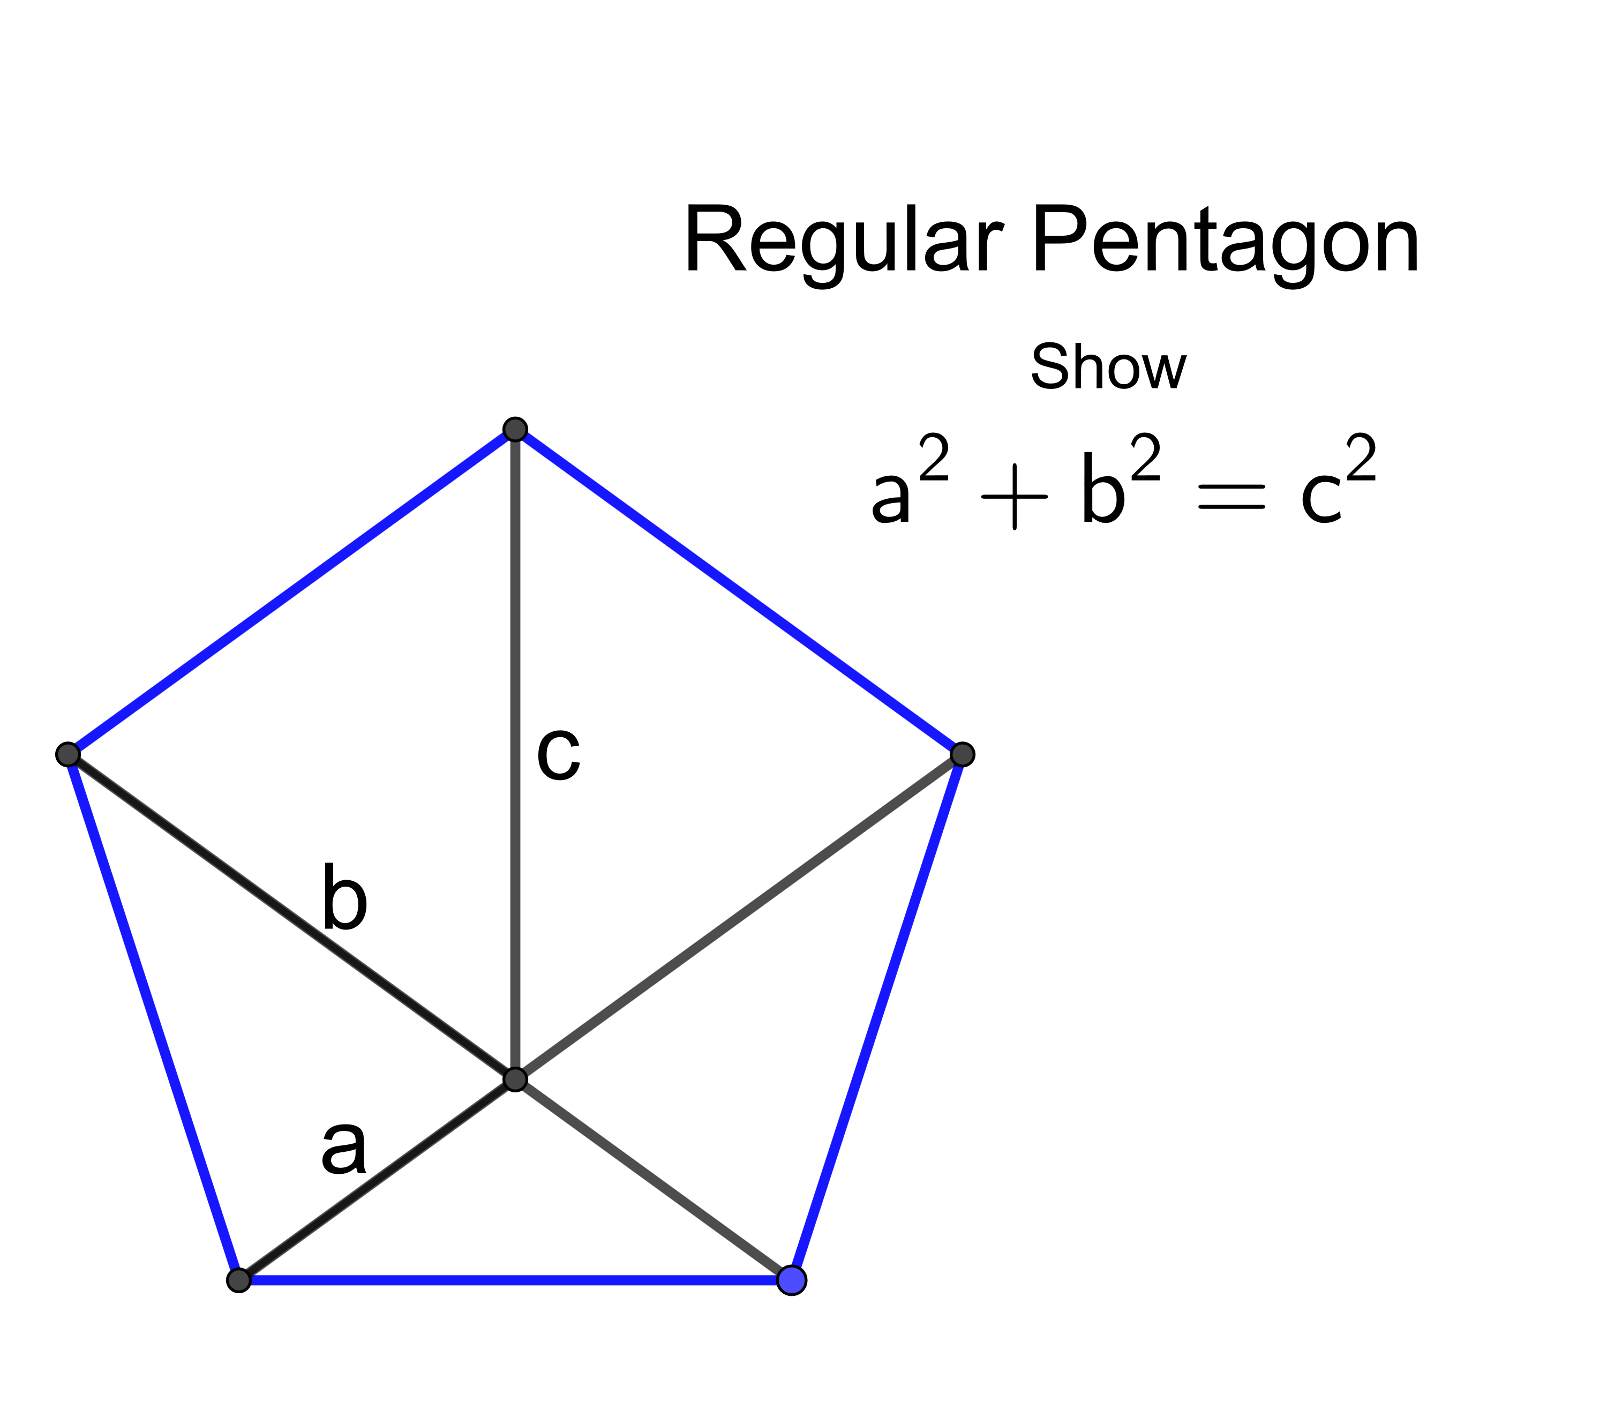
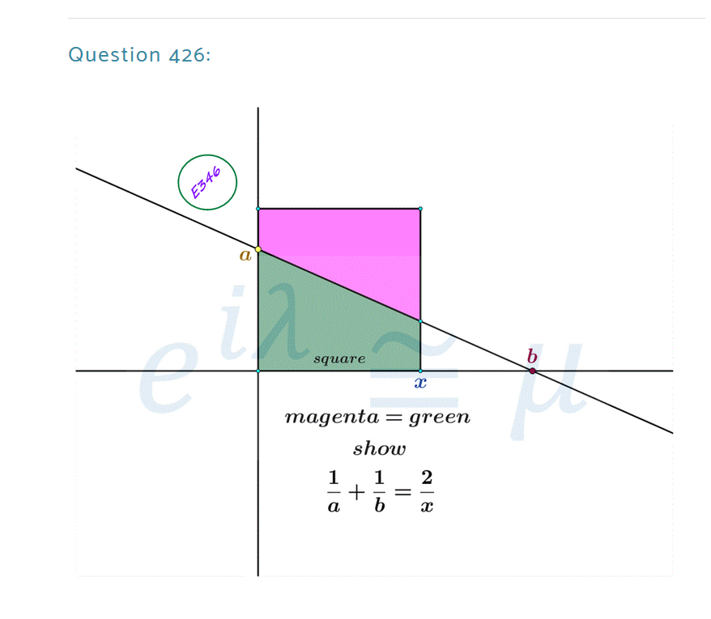
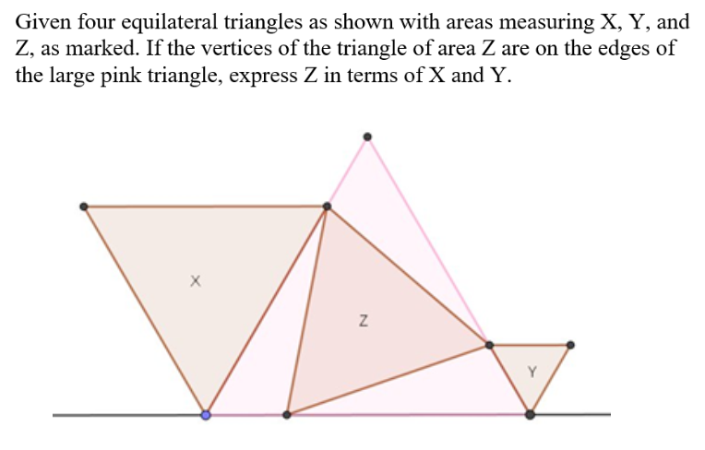
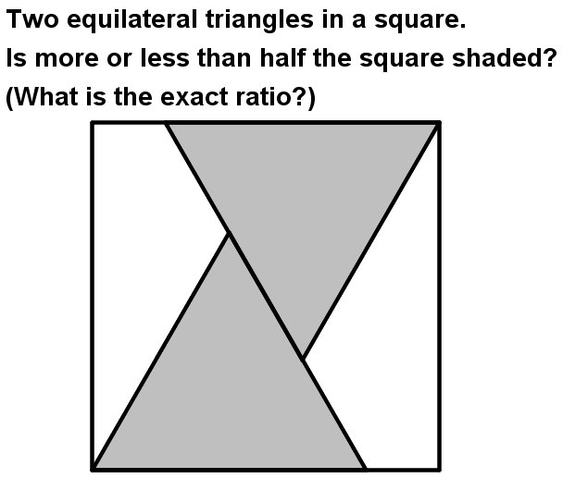
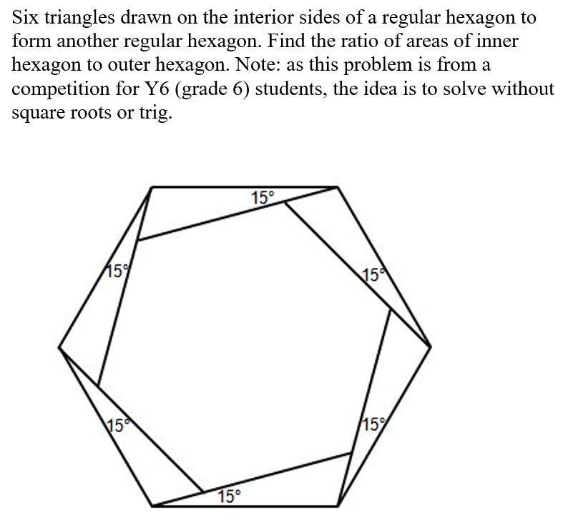
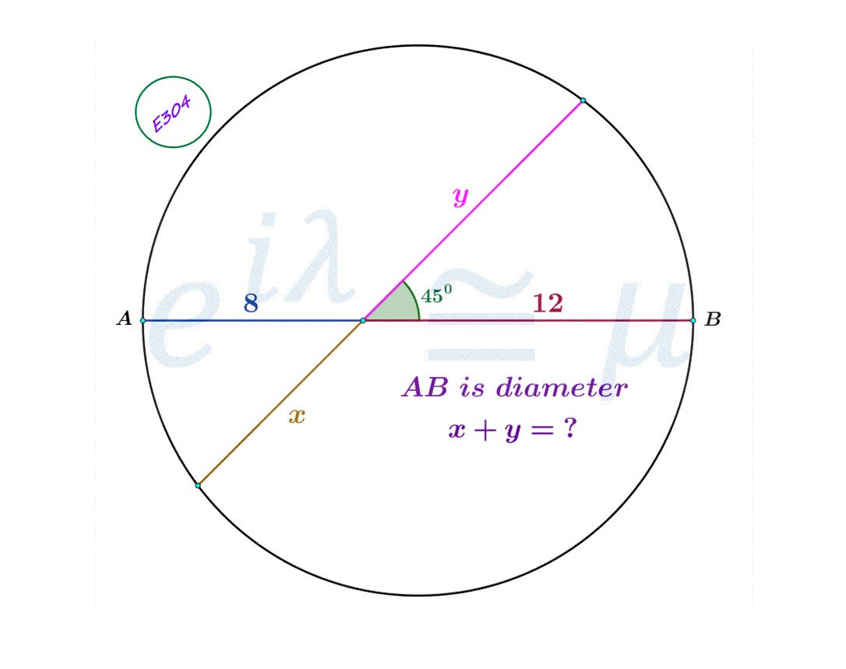
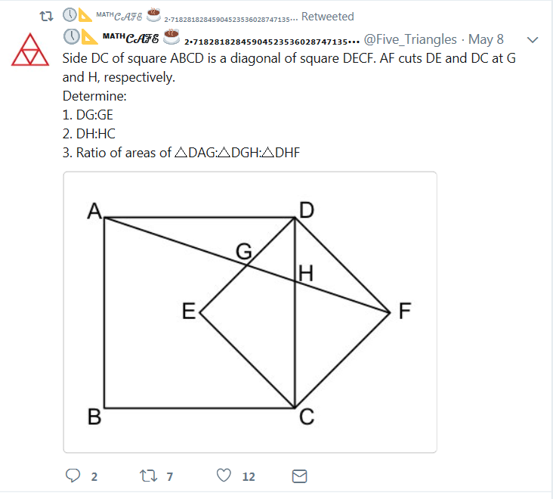
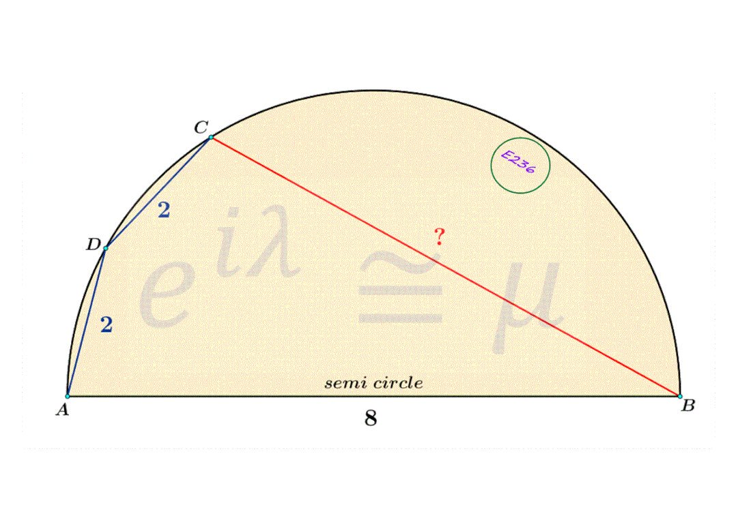
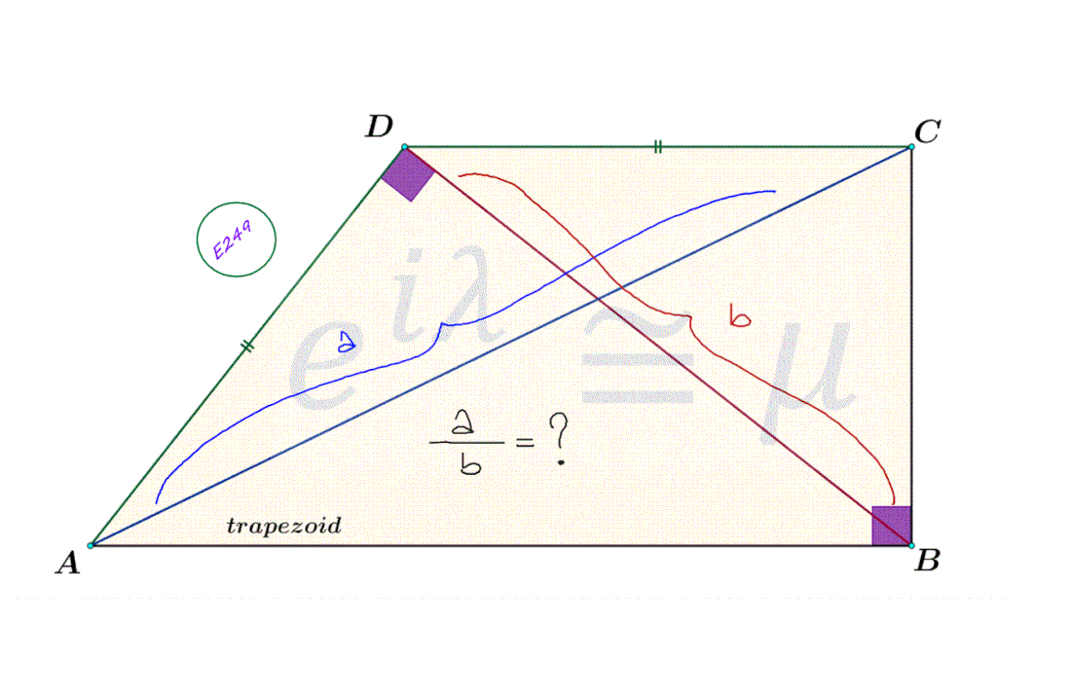
Some Math People to follow on Twitter: @noswald @HenkReuling @mathhombre @PaulaKrieg @_eylem_99 @jldavilaa01 @giohio @mrsforest @DrOlsen314 @jamestanton

