Exam I Answers ~ Math 303

In class portion #3
- 67
- 45.35
- 6

Take Home portion
1. By hand solution:
Let x = the number of $.10 increases.
$f\left(x\right)$ = revenue ($)
$$f\left(x\right)=\left(7.5+.1x\right)\left(4000−35x\right)=−3.5x^{2}+137.5x+3000$$
$$\left(\text{derivative}\right)f^{'}\left(x\right)=−7x+137.5$$
$$\left(\text{solve}\right) 0=−7x+137.5$$
$$x≈19.643$$
Therefore, make 20 ten-cent increases.
Ticket price should be $9.50.

Graphics Calculator solution:
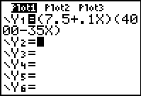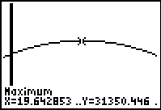
(same conclusion)

Spreadsheet – separate file. Spreadsheet file has solutions to #1 and #2.

#3-5. Answers Vary. See peer solutions.

Point Values:
Item | 1* | 2* | 3* | 1 | 2 | 3 | 4 | 5 | e-mail | Web page | Total
Points | 4 | 8 | 3 | 24 | 6 | 10 | 10 | 10 | 2 | 3 | 80
*in-class items

