Police and Muslim Community Relations

Matthew H. Pecoraro

Instructor: Dr. Lynn A. Tovar

Applied Research Methods

December 8, 2008

Abstract: Police / Muslim Relations
My research paper on / Muslim relations was born from necessity. After hanging around this community for a while to gain knowledge of their customs, beliefs, and the like; there was information, merely being around Muslims was not going to provide. I had heard generalities concerning the police / Muslim community relationship; but I needed to get information with more substance. I wanted to get a true sense, based on and I did not want just a satisfaction survey; I wanted to know their comfort level also. How apt were members of the Muslim community to call the local police when encountering problems within their community. What common types of interactions would Muslims find offensive. Finally, how likely were members of the Muslim community to come to police with information of criminal behavior?
With the help of many members of the local Muslim community, I developed a survey, distributed and collected it and then analyzed the data to discover any important trends. Using my situational awareness, I developed some insights and conclusions as to what the trends mean in context to the overall topic and suggested areas for further research. At some point in the future, I intend to conduct a more in-depth and comprehensive study that will address many unanswered questions revealed during this study.

Table of Contents

Topic Page Number

Introduction 2
Statement of Problem 2
Sub-Problems 3
Delimitations 4
Definition of Terms 4
Assumptions 5
Need for Research 6
Literature Review 7
Muslim Culture Explained 7
Religious Practices 7
Collective Mentality 10
Importance of History 13
Police Interaction 13
Past / Country of Origin 14
Present Experience / Local Police 15
Police Understanding of Muslim Culture 17
Outreach Efforts 17
Formal Muslim Culture Training 18
Arab Language Training 19
Methodology 20
Research Style 20
Survey Questionnaire 20
Development and Content 21
Participants and Distribution 22
Execution 23
Results and Analysis 25
Respondent Demographic Summery 25
Police Understanding of / Sensitivity to Muslim Culture 26
Muslim Community’s Comfort with Police 27
Muslim Community’s View of Police Treatment of Public 29
Muslim Sensitivity to Police interaction with Muslims 29
Conclusion 32
Purpose Restated 32
Author Bias 32
Explanation of Findings 33
Police and Muslim Community Interaction 33
Practical significance of findings 36
Assumption Accuracy 37
References 39
Appendix 42
A. Questionnaire 42
B. Results Matrix 45
C. Charts and Graphs 47
CHAPTER I
Introduction
The purpose of my research is to examine the Muslim Community’s view of local police. In this day and age, horrifying terrorist attacks are being perpetrated by radical Muslims in many countries throughout the world. In addition to this, the traditional look and dress of Muslims, especially Muslim women, is foreign to most Americans. When non-Muslim American citizens see members of the Muslim-American population they see people they know very little about and who they do not understand at all. Many times, they look at the entire Muslim population with an eye of suspicion causing the Muslim population, in turn, to respond in a defensive manner. Police are a subset of the American community and therefore share in their general views and biases.
As the number of Muslim immigrants increases, so too does the number of interactions between these populations. Negative interactions beget negative results which beget more negative reactions. We have seen in France and other European nations how bad things can get when a population is allowed to become alienated. It is with this reality in mind, there should exist, an increased urgency to establish understanding between the two entities.
The Problem
As it is the job of the police, in America, to serve and protect the public and to preserve peace, they have the duty to reach out to the potentially alienated community, in this case the Muslim Community. This cannot be done effectively without first taking inventory of the feelings and viewpoints of Muslim Americans or recent immigrants from Muslim countries. This paper will focus on the Muslim community’s view of the local police and on the job they are doing to understand and build bridges between Muslim and non-Muslim people.
Sub-Problems
In this research paper, I will first explain relevant aspects of the Islamic Culture and past civilization. I will discuss the “collective culture” tradition they come from and why it has an effect on the lens through which they view the world as compared to the “rugged individualism” culture common in the United States. Next, I will discuss the importance of history for this population and why efforts to put history behind them do not come as easy as it does for other cultures. This is no small point and it explains why we too must know what history is and how it impacts the psyche of Muslim Americans. Finally, I will discuss the Muslim faith’s origins, beliefs and practices as well as why this belief set seems so foreign to us here in the United States. I will discuss how the concept of “Sharia Law” applies to this population and how secular law, as practiced in the United States, can be a new concept for recent Muslim immigrants and how it may be a dilemma for them to grapple with.
In the next portion of the paper I will discuss past interaction between members of the Muslim community and the local police. I will start by discussing the fact that Muslim immigrants come from countries where law enforcement entities may act as agents of government intimidation and control leading Muslims from there to have an inherent aversion to initiating contact with police. Here police act with a sense of service to the population. This may not be well understood by these new immigrants. Next, I will discuss the various interactions which may occur between the police and the Muslim population and how police understanding of Muslim culture could affect the outcomes of such interactions. I will review what times Muslims are more apt to call for police services and when they would try to keep out or limit police involvement in a disturbance.
Finally, I will discuss the level of police training, concerning both cultural traditions and language aspects. I discuss whether or not the Muslim population believes police training to be adequate and what challenges may exist when attempting to increase the cultural awareness of a police department.
Delimitations
This research will be limited to 20-30 respondents from within the city limits of Chicago. Also, I am limited to 20 or less questions on the survey to include demographic data. The surveys will be distributed at two local (Chicago) mosques and only at these two mosques. With the time constraints in mind, this is the most expeditious way to get a sampling. This may have a small impact on the overall results because certain nationalities will tend to use certain mosques. Also, Muslims who are not practicing but still identify themselves as Muslim will, most likely, not be sampled using the survey technique used in this study. The responses will mainly concern Muslim interaction with Chicago Police. Due to the sensitive nature of the data being collected and the fact that I will identify myself as a police officer if asked, direct questions addressing my problem or sub-problems cannot be asked. This will lead to deeper interpretation, on my part, of the data collected.
Definition of Terms
The following terms, used throughout the text of the paper, are defined as follows:
Islam: A monotheistic religion characterized by the acceptance of the doctrine of submission to Allah (God) and to Muhammad as the chief and last prophet of God.
Muslim: A person who ascribes to the religion of Islam.
The Quran: The word of God imparted to the Muslim prophet Muhammad in a series or revelations or dreams the prophet experienced from 610 (Common Era) C.E. until his death in 632 C.E.
Hadith: A narrative relating deeds and utterances of Muhammed and his Companions (i.e. the original Muslims)
Sunnah: Habitual practices, customary procedures; sayings and doings of the Prophet Muhammed
Sharia Law: Islamic law which is derived directly from scripture in their holy book, the Quran, and interpreted though the example set forth by their prophet Muhammed, as captured in the Hadith and the Sunnah.
Fiqh: Islamic jurisprudence according to Sharia Islamic law based directly on the Quran, Sunnah and Hadith
Mosque: Gathering place for the Muslim community which is used for many purposes of which the most prominent is worship. Another name for this structure is “mesjid”.
Assumptions
My paper moves forward under the belief of a few assumptions. First, it is assumed the Muslim culture has an inherent distrust of western secular authority, in general, and of local police specifically. Also, recent immigrants will have among the highest levels of distrust of police. My third assumption is Muslim women, who can bring a different point of view to the table, are often hesitant to participate and therefore are under-represented in the communication process with police due to norms in Muslim culture. My fourth assumption is the phenomenon of collective (tribal) culture leads to further suspicion and mistrust between the Muslim culture and police. My final assumption is efforts to improve communication and understanding are desired by the Muslim community and can only help improve overall stability of society.
Need for Research
I have done much research on Islam and on Muslims. I have become aware of potential problems which can occur within our American society as have been demonstrated in other, European, democratic western societies. Alienation of Muslims in those communities, whether self imposed of imposed on them by the non-Muslim society, has resulted in riots, hard feelings and terrorist attacks. The percentage of Muslims in our population is much lower than in European countries, but it is on the rise. It is the responsibility of the police to ensure peace and security within our society. If we can assess the opinion of the Muslim population concerning the police and police efforts to improve the situation, we can determine where we are going right or wrong and move now to fix the situation before it gets away from us.

CHAPTER II
Statement of the Problem
The purpose of my research is to examine the Muslim community’s view of local police. To this end, I have looked into the existing literature in an effort to determine a baseline of understanding to focus this study.
Muslim Culture Explained
Religious Practices
Before I begin, I feel the need to give you, the reader, a basic understanding of the Muslim community. This necessary because unlike the rest of the world where the Muslim population makes up approximately 20 percent of the population (Adherents, 2007), the Muslim population within the United States (U.S.) makes up less than one percent of the overall population (CIA, 2008). People who grow up within the borders of the U.S. interact with Muslims far less often than residents of most countries outside its borders. Due to this fact, the average American has relatively few experiences they can draw from when trying to get a proper perspective of the Muslim community.
The first aspects of Muslim culture I will discuss are their religious practices. The purpose for bringing this up is simply to provide a basic understanding of some of the daily religious requirements which are inherent to the life of a Muslim. In an introductory textbook for children concerning Islam, it is stated there are five main practices (pillars) of Muslim life which are performed as a way to get closer to Allah (Muslim name for God) and to strengthen themselves from the influence of Shaytan (Muslim for the devil) (Emerick, 2005a, pp 34).
The first practice of Islam is the statement of their faith, which is; “I declare there is no God but Allah and I declare Muhammad is the messenger of Allah” (Emerick, 2005a, pp 35). If a person wants to become a Muslim, they only need to state this one sentence, believing what they are saying is the truth, and they can be considered a Muslim (Emerick, 2005a). In addition to this, there are seven various versions of this statement which can be said whenever a Muslim wishes to affirm their belief. They are called Kalimas (Emerick, 2005b, pp 183).
The next practice of Islam is Salaat. In a textbook for very small Muslim children, it explains Salaat is the practice of praying five times a day. There are five benefits to saying these prayers. First, it reminds the person of the existence of Allah. Second, it allows for the forgiveness of sins. Third, it helps you to feel good about yourself. Fourth, it helps to keep the devil away from you and fifth, it cleans your heart (Emerick, 2005b, pp 183).
Muslims perform Salaat at certain times which will change from day to day. Wherever they are in the world, they are to face the city of Mecca, Saudi Arabia (Ahmed, 2002). Three times of day must be avoided so as not to be associated with sun worshipers. Those times are sunrise, when the sun is in the middle of the sky (around noon) and finally, at sunset (Mohamed, 2005). A Muslim can perform Salaat by themselves and wherever they desire, but it is preferred they perform Salaat in congregation (three or more together). This helps to build unity among all Muslims (Mohamed, 2005). Friday is viewed as a community day and so, especially for males, the middle prayer of the day should be done in congregation at a mosque (Mohamed, 2005).
The third practice of Islam is Zakat. It is charity in the form of monetary donation through an administrator to the needy. Depending on the item of worth, the yearly collectable amount can range from zero to twenty percent of the worth of an item. The sum should be paid at a designated time each year, but under certain circumstances, can be paid in installments throughout the year (Kahf, 2001).
The fourth practice of Islam is Sawm (fasting) during daylight hours of the ninth month of the Islamic calendar called Ramadan. Ramadan has between twenty-nine to thirty days due to the fact the Islamic calendar is based on the lunar cycles and therefore is flexible. There are multiple purposes for fasting; among them are the reminders of the difficulties encountered when following Allah; to remember the plight of people in the world who have to cope with the daily challenge of little to no food; to build self discipline and brings all Muslims together. This is done during the Islamic month of Ramadan because this is the month in which Muhammad first received his messages from Allah (Ahmed, 2002). Fasting is described as follows:
“Fasting is not just refraining from food or drink; there must be no sexual intercourse, no tobacco, no backbiting, no lying, and so on. If, however a Muslim eats or drinks something by mistake, then the fast may be continued as before and it is not nullified. If the fast is broken intentionally it must be compensated for by keeping a number of consecutive fasts or feeding the poor people. Those who are very old or sick, or on a journey, or women in menstruation are exempted from fasting, since fasting generally begins at puberty, children are also exempt” (Ahmed, 2002, p 34-35).

Fasting during Ramadan causes the Muslim population to focus on their faith. They will go to the mosque more often. They will try to read the Quran more and there will be more efforts for charity, such as feeding the poor. Another outcome of the restrictions Muslims are under is the fraying of nerves which can occur during this time; this especially true of people addicted to cigarettes or dependent on coffee or tea (Ahmed, 2002). At the conclusion of Ramadan, a holiday called Eid al-Fitr is celebrated with visits to friends, gift exchanges and large feasts.
The fifth and final practice of Islam is Hajj (pilgrimage). It is a once in a life-time, five day pilgrimage to the city of Mecca, Saudi Arabia during the twelfth month of the Islamic calendar (Dhu al-Hijja). This is done in the tradition of Muhammad, who also made a pilgrimage to Mecca this way. There are very specific ways of dress, procedures to follow, acts to perform and mentality to have in order to perform hajj successfully. An additional requirement is one who makes the hajj must pay for the trip themselves without borrowing money to do so, and they must be able to afford the trip (Ahmed, 2002).
On the final day of the hajj, another holiday called Eid al-Adha is celebrated with visits to friends, gift exchanges and large feasts. Since few individuals can meet the strict rules regarding the attempt of completing the hajj, Muslims who are successful in their attempt return to their communities as highly respected individuals known as hajjis (Ahmed, 2002).
Collective Mentality
The next aspect of Muslim culture I will discuss is the collective or tribal mentality which is pervasive among Muslims. This mentality is best captured by the concept of “The Ummah”. In his book, Islam Today: A Short Introduction to the Muslim World, Akbar S. Ahmed states:
“The concept of the ummah, community or brotherhood, may be intangible and even amorphous but it is powerful. It allows ideas to be carried across national borders and can generate emotions wherever Muslims live. It is the notion of the ummah that triggers a response when Muslims see or hear scenes of other Muslims being denied their rights or being brutally suppressed when voicing them” (Ahmed, 2002, p 8).

This quote demonstrates Muslims of all nationalities share a common, collective lens through which they view the world. In addition, studies have shown the adherence to this collective religious identity remains with immigrants from Muslim dominated countries who relocate to westernized countries much longer than adherence to cultural or religious behaviors of other ethnicities or religions. In a recent study it is stated:
“The average Muslim individual clearly appears to be more attached to her / his culture of origin. Indeed, regardless of the dimension of identity considered, the percentage of Muslims having an intense religious identity is roughly twice as much as that of non-Muslims. A greater resistance to cultural integration is also signaled by the percentage of Muslims speaking English at home or with friends, always significantly lower than those of non-Muslims. Finally, Muslims have almost twice the probability of having a marriage arranged by their parents than non-Muslims, also a sign of attachment to cultural and religious traditions” (Bisin, Patacchini, Verdier, Zenou, 2007, p 4-5).

We see here, members of the Muslim community have a higher propensity to adhere to cultural values than non-Muslims. These cultural values are, in many cases foreign to the local community, including the police, who do not understand or agree with them. This misunderstanding will obviously have negative implications on relations between the two groups.
One last component of Muslim life is Sharia law. In the early stages of existence for the new Muslim faith, old autocratic laws and the new religious based laws were not applied equally to the various communities and strata of society. This worked when Muslims were the minority; but as they became the majority, the various applications of the law became unmanageable. In the late 700s to the late 800s C.E., detailed accounts of how Muslims lived while Muhammed was alive, what Muhammad said and did pertaining to everyday living were collected and a new comprehensive universal form of Sharia law was formed (Armstrong, 2000). This concept is best captured through this quote:
“Two sound and authoritative anthologies were compiled by al-Bukhari (d. 870) and Muslim (d. 878), which stimulated interest in fiqh and led eventually to the creation of a homogenous religious life, based on the sacred law of the Shariah, throughout the vast Islamic Empire. The inspiration of the law was the person of the Prophet, the Perfect Man. By imitating the smallest detail of his external life and by reproducing the way he ate, washed, loved, spoke and prayed, Muslims hoped to be able to acquire his interior attitude of perfect surrender to God” (Armstrong, 2000, p 60).

Armstrong goes on to say how this new law system applied not only to religious or moral matters but to all aspects of life. It spanned the entire worldwide Muslim community (Armstrong, 2000). This is another aspect of a cultural obligatory tie.
Language is one component of what makes a certain population stand out from other cultures. In the Muslim community it is the Arabic language. Islam is not just a religion but a complete way of life. “It is as if one single document contained the U.S. constitution, our legal code, national education policy, business practices, inter-personal etiquette and the bible” (Badolato, 2004, p 9). Muhammad received his message from Allah in Arabic. The Language of the Quran is Arabic. When translating a written document from one language to another, some meaning is lost. When the meaning is coming straight from God, misinterpretation of the meaning must be avoided. For this reason regardless of nationality, Muslims are highly encouraged to learn Arabic. This brings Arab cultural aspects into the religion of Islam (Badolato, 2004). “Pride and sensitivity, the ideal of manly virtue, the Arabic language, dignity and the all important concept of honor are all interwoven between Islam and Arabism” (Badolato, 2004, p 10).
One aspect of this collective culture is honor. “Honor (sharaf) has been highly valued since early Arab history because it was conducive to group cohesion and survival” (Badolato, 2004, p 10). Honor is so important to the Arab mindset that any slight of honor can have serious consequences. This honor concept also has a collective aspect. One’s own honor, positive or negative, also reflects directly upon the honor of the family or clan. Damage to a person’s honor can also have economic impact on them and have been at times, grounds for successful lawsuits. (Schmadeke, 2007). Occasionally, it degenerates into what is known as a blood feud between families or family members (Eiserer, 2008). In any conflict, it is important to leave a way for someone from this culture to have an outcome where they save face (Badolato, 2004).
Importance of History
I could not find much writing about it, but there is another underlying influential concept which has an impact on the way Muslims view the world. Significant past events are viewed as having a direct impact on and relevance to a contemporary issue. This concept can be captured in the following quote:
“When asked why the Iran-Iraq war began, one Arab historian noted it really began at the battle of Qaddisiya over a thousand years ago when Muhammed’s son-in-law, Ali, was defeated by the forerunners of today’s Sunni Arabs” (Bisin, Patacchini, Verdier, Zenou, 2007, p 5).

We also see importance of historical events in the practice of Muslims performing everyday practices in the same manner in which Muhammad, their prophet, did them (a practice called Sunnah). An example of this would be the opening of fast during Ramadan by eating a date (a fruit which has symbolic meaning for Muslim culture). Although there are many reasons extolled for the practice of breaking fast with the eating of a date; the main reason is it is done out of reverence for historical precedence set by Muhammad (Ahmed, 2002).
Police Interaction
In a Muslim produced manual for police, it has a section on Muslim perception of law enforcement officials. It lists the following five perceptions:
- Police (in the U.S.) are perceived in the same (light) as in the country of origin: corrupt, open to bribery, brutal.
- Arab and Muslim American males believe they are automatic suspects.
- There is generally a high respect for authority.
- Law enforcement agencies are perceived to be the same authority (FBI, INS, US Marshal, Customs, LEO).
- There is a general mistrust and a belief that homes, phones, financial transactions are bugged or traced.
Muslim Public Affairs Council (2005, p 11).

So, we do not have to guess as to Muslim’s views of police. I will give some specific examples to support this notion.
Past Experience / Country of Origin
First, concerning Pakistan, an article discussing police engaging insurgents it is noted, Frontier Police chief Malik Naveed Khan stating he is trying to re-build trust between his police and local people because “some police have been accused of extorting money from people eager to avoid being tagged as Taliban” (Barker, 2008). In another article, again concerning Pakistan police, it is stated “The police have essentially served as a private militia for the prime minister and his or her family” (Eteraz, 2008).
Additionally it states “The officers would have to be paid enough so they do not take kickbacks from politicians and feudal lords” (Eteraz, 2008).
In a third example, this time from Iran, an article from the Human Rights Watch stated “Iranian police and plainclothes agents yesterday charged a peaceful assembly of women’s rights activists in Tehran and beat hundreds of women and men who had gathered to commemorate International Woman’s Day” (Human Rights Watch a, 2006). From Indonesia, the human rights group reported “In the Central Highlands of remote Papua province, a region closed to outside observers, police appear to be routinely committing serious abuses, such as extrajudicial executions, torture and rape, with impunity” (Human Rights Watch b, 2007).
Finally, it is stated, in an article from the British Broadcasting Corporation (BBC) about news being reported in Saudi Arabia, “Saudi Arabia’s religious police stopped school girls from leaving a blazing building because they were not wearing correct Islamic dress” (BBC News online, 2008). The article goes on to say the police stopped men who tried to help the girls, saying it was sinful to get near them since they were not dressed properly. All fifteen girls burned to death.
Present Experiences / Local Police
The problem is not contained to past experiences. These past experiences have left Muslims in America suspicious of the actions of local police here in the United States. One example of this occurred in Los Angeles, California. The Los Angeles Police Department (LAPD) wanted to use United States census data to map demographic locations for the Muslim population and then direct social services sensitive to the population to those areas. The problem came when the Muslim population discovered this effort to map out their community locations. They saw this as an effort to profile them (Watanabe,T., Winton, R., Krikorian, G., 2007). Later, in a move applauded by representatives of the local Muslim community, the LAPD was forced to abandon their plan, seen as a major reversal of department policy with the stated goal to identify “potential hotbeds of extremism” (Watanabe,T., Winton, R., 2007, p 1).
Salam Al-Marayati, executive director of the Muslim Public affairs Council stated “Muslim Americans were very disturbed and concerned about the ramifications of the plan and having their privacy invaded” (Watanabe,T., Winton, R., 2007). When addressing the abandonment of the data collection plan, Al-Marayati stated “It’s the first step to very healthy dialogue between Muslim Americans and the city of Los Angeles” (Watanabe,T., Winton, R., 2007, p 1).
In New York in August 2004, a terrorist plot to detonate a large bomb in the Herald Square subway station, in a large shopping district downtown near Macy’s department store, was broken up by two counter-terror investigators who had been planted in the Muslim community. During the trial of the Pakistani immigrant, who was found guilty of all four counts against him, leaders of the Muslim community made statements complaining the investigation proved Muslims were being targeted.
One Muslim leader stated “She was saddened the police had resorted to F.B.I. Tactics” and the investigation was polarizing to the Muslim community (Elliott, 2006, May 27, p 1). Another Muslim community representative and liaison to the New York Police Department stated “This is a real setback to the bridge building. We had meaningful meetings. We thought we were going somewhere with this” (Elliott, 2006, May 27, p 1). A Muslim community activist complained, “They (police) want to be formally introduced to the community but they don’t need to be, they already have their informants among us” (Elliott, 2006, May 27, p 1). Not all members of the Muslim community there felt the same. One Muslim, Egyptian immigrant to New York stated “They have to watch the community. I’m trying to defend the image of my religion, if someone is doing that, (entertaining thoughts of performing terrorist acts) they have been brainwashed” (Elliott, 2006, May 27, p 1).
There are cases where the gray area for officer reaction is even more unclear. One such case occurred at a Veteran’s Affairs (VA) hospital in Syracuse, New York. A journalism student at Syracuse University and quasi-intern with the Syracuse Post-Standard newspaper had just come from a photography class and was walking by the hospital when she stopped to take some pictures. She happened to be Muslim and was wearing long pants, long sleeves and a headscarf. She was stopped by VA Police who questioned her about photographing the entrance to the building. She was directed and complied with an order to delete the photographs of the building entry but was brought in for further questioning anyhow. While in custody an officer deleted more of her photos without asking or notifying her. Also, they took and photographed her identification cards and inquired about her citizenship and she told them she was a U.S. citizen born in Michigan. When released, the journalism student, apparently shaken up by the incident, reported it to her supervisors at the newspaper. This set off a war of words between the VA Police and the newspaper and is used by members of the larger Muslim community as an example of bias against them by police (Rothchild, 2007).
Police Understanding of Muslim Culture
Outreach Efforts
Outreach efforts to the Muslim community by local police departments have been plentiful. In Houston the police Chief, Harold Hurtt, stated “I recognize the importance of reaching out to our city’s Muslim population” (USINFO, 2007, February 5, p 1). A Pakistani born officer on the Houston Police Department, Muzaffar Siddiqi, stated “There is fear of police in some Muslim countries, and many Muslims in the United States have to be taught to trust law enforcement (USINFO, 2007, February 5). When discussing conditions in his homeland of Pakistan, Siddiqi stated “People do not often seek out help from police officers; instead, they hide from them” (USINFO, 2007, February 5, p 1).
In the 1990’s, the police in Dearborn, Michigan, established their community policing center in the middle of the Arab-American commercial and residential district and have worked to build ties to that population. The police Chief, Michael Celeski stated, “After 9-11, we were able to reach out and personally meet with community leaders and assure them the city and the police would be working together to protect them from retaliation” (USINFO, 2007, February 5, p 1).
In San Jose, California, police Chief Rob Davis saw the benefit to building a trusting relationship with the local Muslim community, so he made the decision to fast during Ramadan and break the fast each night with his Muslim neighbors. Chief Davis is a Mormon (USINFO, 2007).
Formal Muslim Culture Training
In an article from The Christian Science Monitor, it states many law enforcement agencies across the United States, to include the Federal Bureau of Investigation (FBI) are educating their members concerning Muslim and Arab culture. (MacDonald, 2006, December 15). In New York, about 100 members of the Department’s hostage negotiation team went through a day long training session leaning how to build cooperation in the Muslim community by learning Muslim customs. Members of the Houston Police Department went to mosques during paid time in order to build understanding of the Muslim culture (MacDonald, 2006, December 15).
Some training does not originate with an officer’s department. In Kentucky, The Kentucky Islamic Resource Group (KYIRG), a community-initiated outreach organization, has taken it upon themselves to reach out to police with awareness level courses which are academic, not devotional in nature. In other words, they do not promote Islam or degrade other faiths. The courses are two to four hours long and are meant to supplement a department’s existing cultural diversity training (KYIRG, 2008).
Another example of community-initiated outreach programs is one hosted by the Islamic Cultural Center of Fresno. This organization has initiative started to reach out to the non-Muslim community in which it finds itself. Additionally, they reach out to other faith traditions by way of interfaith programs and they also reach out to the police. They have general diversity training offered to many organizations and they have a two hour block of instruction specifically designed for local police (Abu-Shamsieh, 2008).
Arabic Language Training
Language is a very important aspect of a culture and if a culture is to be understood, an effort to know the language is important. This concept holds true for the Muslim population. In an online information website, it states:
“Ninety percent of the world's Muslims do not speak Arabic as their native language. Yet in daily prayers, when reading the Qur'an, or even in simple conversations with each other, Arabic rolls off any Muslim's tongue readily. It may be broken or heavily accented, but most Muslims make the attempt to speak and understand at least some Arabic” (Huda, 2008, p 1).

We see here, even non-Arab Muslims are encouraged to know some Arabic as it is one thing which helps bind the community together. The use of the Arabic language brings with it other Arabic influences. This idea is captured in the Sapir-Whorf hypothesis which states “there is a systematic relationship between the grammatical categories of the language a person speaks and how that person both understands the world and behaves in it” (Nationmaster, 2008, p 1). Although this idea has been debated, any outside observer of the Muslim community would come away admitting the Arab cultural influences are present. I have found little to no documentation of movement on the part of local police departments to stress Arabic language proficiency as a goal for its officers, but encouragement and facilitation of that type of training may be in the near future.

CHAPTER III
The purpose of my research is to examine the Muslim community’s view of local police and the job they are doing to understand and build bridges between Muslims and non-Muslims. The problem I wanted to gain insight into first was the collective mindset Muslims are assumed to possess. Second, the level of adherence to Sharia law local Muslims are assumed to be strong in. Third, the distrust Muslims are believed to have toward the police.
Style
The method of research I chose for this paper was quantitative. “Quantitative research is used to answer questions about relationships among measured variables with the purpose of explaining, predicting, and controlling phenomena” (Leedy, Ormrod, 2005, p 94).
Survey Questionnaire
In my opinion, the best way of obtaining information concerning my topic was to develop a paper questionnaire and distribute it to members of the Muslim community, collect completed questionnaires, then tally and analyze the results. Due to my assumption, members of the Muslim community view police actions with suspicion and the fact I am a police officer, I knew the way the questions were phrased and how I presented the questionnaire to the respondents would be a delicate situation and could influence the results. I used an “Ordinal Scale” for my respondents to use when responding. “With an ordinal scale of measurement, we can think in terms of the symbols > (greater than) or < (less than). We can compare various pieces of data in terms of one being greater or higher than another. In essence, this scale allows us to rank-order our data (hence its name ordinal)” (Leedy, Ormrod, 2005, p 26). I used this scale because I thought it was the least impersonal and cold. I felt it allowed me to capture feelings as well as facts.
Development and Content
To gain additional insight to this dilemma, I contacted some Muslim organizations whose mission is community outreach. I spoke to a few members of The Council of Islamic Organizations of Greater Chicago (CIOGC) about my research idea and the concerns I had about the conduct of my survey. The validity of my concerns was confirmed and I was provided input concerning various aspects of the survey development and distribution process.
The first aspect we discussed were the questions to be asked in the questionnaire. I told the Muslim community outreach representatives the main problems and sub-problems which had arisen from the literature review. We then worked together on what exact questions were appropriate to ask and the best way to phrase the questions. Not only did we discuss the questions addressing the research problems, but also the questions concerning demographic information of the respondents. The Muslim community representatives informed me, as an initial research project, the questions should be general in nature. Also, because I was not well known to the community, the tone of my questions and the information requested needed to be viewed as the least intrusive questions possible.
After this discussion, I wrote up a tentative questionnaire. I sent it out to the Muslim community representatives who reviewed the questions and provided further advice on the wording and content. After a few more consultations, the development process for the questionnaire was complete and we moved on to the process of conducting the survey. I was referred to another contact person who was not only a representative of the Muslim community; but was also a Chicago Police Officer. This gentleman, I’ll call him Hasan, contacted me and offered to meet about the project. Participants and Distribution
During the meeting and subsequent phone conversations we worked out a plan for survey distribution and collection. Using contacts which I had established at a mosque on Chicago’s northwest side, I would set up a time to personally distribute and collect surveys inside the mosque during their Friday community prayers. The Muslim community which attends that mosque is mainly “blue collar”, middle to lower-middle class individuals. Also, the percentage of recent immigrants to the United States is larger at that mosque and I wanted to ensure I had their input.
As for Hasan, he would take surveys to a mosque located in downtown Chicago during the same Friday community prayers. The downtown mosque was frequently used for survey dissemination. The people who attend that mosque are “white collar”, middle to upper middle class individuals. This is another population I wanted to be sure to capture input from. He would distribute and collect the surveys and would return the completed surveys to me afterward.
An additional measure I took was to develop an information block which would be printed on the cover page of the survey questionnaire. In it I explained who I was, the research I was conducting, why I was conducting this survey, how the information was to be used and my privacy policy. I also noted the survey, although asking questions concerning the local (Chicago) police; was not authorized by the Chicago Police Department.
I printed out 30 surveys. I knew this was more than I needed, but I wanted to make sure if people took some and did not return them, I still had enough to complete the process. Next, I put the three page (see example in the Annex A of this paper) questionnaire inside a blank manila envelope which could be glued shut after the completion of the survey. I also attained 30 black ink pens with no markings on them, and included them in the envelope also.
The day before the survey was to be conducted; I made up an information sheet which could be displayed from my survey collection bin. The information sheet contained all the information on who I was, where I was from and what I was doing. I did this because I did not want to have to explain my presence there to everyone. This had the potential to be very disruptive during a time when they may not appreciate it.
Execution
I met with Hasan the morning of the surveying process and gave him 15 of the survey packets. He went to the downtown mosque as agreed to and distributed the surveys. He had to leave before he had a chance to collect all the surveys and so a friend of his who worked security at the mosque distributed and collected as many as he could. By the end of the day Hasan had collected 12 of his 15 surveys completed.
Later that day, I went to the mosque on the northwest side of Chicago with my 15 surveys. By the end of the day, I had collected 9 completed surveys. I took my 6 remaining uncompleted surveys next door to the Islamic Reading Room and left them with an employee I know there. He said he would try to get the last 6 surveys completed for me. I returned 3 days later and picked them up.
In the end, I collected 26 completed surveys, a fairly high, 86 percent, return rate. All surveys were marked according to where they had been collected. The data from the surveys was entered into a large spreadsheet for analysis. I calculated percentages for each question on the survey and began to look at the content data in comparison to the demographic data, the research problem, sub-problems and assumptions. I developed several themes for which the interpreted data revealed insights into. In the next chapter, I will discuss this data and these themes more specifically.

CHAPTER IV
I will begin the results portion of my paper by identifying some overall trends in the demographics of my respondent population. It is important to note the percentages will not always add up to 100 percent. This is due to rounding of the percentage numbers either up or down to the nearest percentage point.
Respondent Demographic Summary
To begin, the vast majority, approximately 97 percent, were between the ages of 25-70. About 80 percent of the respondents identified themselves as either Arab or South Asian. Concerning gender, 88 percent of respondents were male and 11 percent female. I found it a challenge to get female participants. At my distribution location, the Northwest Side of Chicago Mosque (NWSM); not one female approached me to even inquire as to what I was doing. The only Muslim female who spoke to me about the survey, was the lady who had been my point of contact for setting up the appointment to conduct the survey in the first place.
When it came to higher education a whopping 92 percent had some college, with 23 percent having bachelor’s degrees and the largest percentage, 46 percent, having master’s degrees or higher! Combined, 60 percent of respondents have Bachelor’s degrees or higher levels of education. Downtown Mosque (DTM) averaged 58 percent had a Master’s degree or higher opposed to 44 percent at the NWSM. Income levels were pretty evenly represented with those making less than $30,000 per year in the slight majority, coming in at approximately 11 percent. Once again, there was a difference between locations with the percentage of DTM respondents making over $50,000 coming in at 86 percent; whereas, the percentage of NWSM respondents who made over $50,000 came in at only 14 percent.
Overall, 73 percent of respondents had immigrated to the United States. At the DTM the average was 58 percent and at the NWSM the average was 86 percent. As for number of years spent in this country, my response may not be accurate as I had a typographic error on my questionnaire. If you refer to question nine of the questionnaire in the appendix of this paper; the third and fourth choice gave the same year span, 20-30 years, and the year span 10-20 years was not represented. I believe, though, most respondents picked up on the error and chose the spot which should have stated 10-20 years if is how long they had been here, even if the choice on paper was 20-30 years. I believe this to be true because one respondent actually wrote in the proper year span and checked it and others, when I compared other answers, answered this question so it was consistent with other answers. I can eliminate the problem by stating simply 81 percent of respondents stated they had been here more than 10 years.
The final demographic statistic concerns the respondent’s view of their own religious practice. Here we see the majority, 61 percent, saw themselves as very observant of their faith. Somewhat observant and slightly observant both came in at 19 percent with zero respondents stating they were not observant. Obviously, the fact that we were taking this survey inside of mosques explains this result. It should not be extrapolated, all who identify themselves as Muslim would say they are observant, practicing Muslims. I know a few people who call themselves Muslim who would classify themselves as not observant, so I know such people exist. It is just the design of this survey all but eliminated their participation.
Police Understanding of / Sensitivity to Muslim Culture
I attempted to address the subject of the Muslim community as a whole sharing an identity or collective thought with my eleventh and twelfth survey question. By asking about the local police’s understanding and sensitivity of Muslim culture, I knew the response would be dependent on the accuracy of their own knowledge and sense of Muslim culture. For question eleven, concerning local police understanding of Muslim culture, the split was 50 / 50 percent (See Appendix C, Figure 1) for those who said they agreed police understood Muslim culture and those who said police did not understand. One interesting note was, of those who said they were born in the United States (U.S.), 86 percent said police did not understand Muslim culture. Only 37 percent of those who said they had emigrated to the U.S., said police did not understand Muslim culture (See Appendix C, Figure 11).
This trend repeats itself in the response to question twelve of the survey. When asked if police response to Muslim related calls for service is culturally sensitive; the majority, 68 percent, agreed or strongly agreed (See Appendix C, Figure 2). Of those who responded negatively, 28 percent disagreed and only 4 percent strongly disagreed. Once again though, when looking at origins, 43 percent of those who claimed to be U.S. born responded negatively (disagreed or strongly disagreed), where only 26 percent of foreign born respondents did the same (See Appendix C, Figure 12).
This result could mean people born here in the U.S. are more apt to complain about police service. It could also mean they hold police to a higher standard than do immigrants, who many times come from countries where police are known to not only be rude and unfair, but also very brutal. Finally, it could mean U.S. born respondents understand Muslim culture differently than immigrants and in am attempt to demonstrate their Muslim identity, become quick to take offence to any perceived slight. In any case, with these two questions, it seems to come out, U.S. Born Muslims are more critical of local police.
Muslim Communities Comfort with Police
The next series of questions concern the respondent’s likelihood to call police for service. When someone calls police for service, they must feel comfortable and confident the police will help them and not hurt them. If they do not feel this comfort, they will not initiate contact and the community will remain unserved by the police.
The series of three questions, asked if the respondent felt comfortable calling police for non-violent and violent related incidents or to provide information of criminal activity. For all three questions more responded positively (they did feel comfortable calling police) than negatively.
Specifically, for question number thirteen, I feel comfortable calling local police for non-violence related incidents, 69 percent of respondents said they agreed or strongly agreed as opposed to 31 percent who disagreed or strongly disagreed (See Appendix C, Figure 3). For question fourteen, I feel comfortable calling local police for violence related incidents, 81 percent agreed or strongly agreed as opposed to 19 percent who disagreed or strongly disagreed (See Appendix C, Figure 4). Finally, for question fifteen, I feel comfortable calling local police to provide information on criminal activity to them, 65 percent agreed or strongly agreed, whereas 35 percent disagreed or strongly disagreed (See Appendix C, Figure 5).
One very interesting dynamic arose when I looked at the responses in light of country of origin for the respondent. Even though, for each of the three questions in this series, the majority of immigrants responded in a positive manner; when I looked specifically at who responded negatively to the questions, a different picture for how some immigrants view police was seen.
For question number thirteen, of those who responded negatively to feeling comfortable calling local police to report non-violence related incidents, 87 percent were immigrants (See Appendix C, Figure 13). For question fourteen, of those who responded negatively to being comfortable calling local police to report violence related incidents, 100 percent were immigrants (See Appendix C, Figure 14). Finally, for question fifteen, of those who responded negatively to feeling comfortable calling local police to provide information on criminal activity 89 percent were immigrants (See Appendix C, Figure 15).
Muslim View of Police Treatment of Public
The next series of two questions dealt with the Muslim community’s view of local police treatment of the community. In both questions, once again, the overwhelming majority viewed the police in a positive light (local police treated the population fair “always” or “most of the time”). Relatively few responded negatively (local police treated the population fair “seldom’ or “never”). For question sixteen, are local police fair in their dealings with the public, 84 percent responded positively as opposed to 15 percent responding negatively (See Appendix C, Figure 6). For question number seventeen, are local police fair in their dealings with the minorities, 69 percent responded positively and 31 percent responded negatively (See Appendix C, Figure 7).
When looking at immigrants specifically, again, the majority always responded in a positive manner, 84 percent of immigrants responded positive to question sixteen and 74 percent of immigrants responded positively to question seventeen. Of the negative responses though, 75 percent of negative responses to question sixteen came from immigrants (See Appendix C, Figure 16) and 62 percent of negative responses to question seventeen came from immigrants (See Appendix C, Figure 17). This response is less stark than for the previous series of questions, but we can see again, for both questions in this series, the majority of negative responses come from immigrants.
Muslim Sensitivity to Police Interactions with Muslims
The final series of three questions dealt with the Muslim community’s view of police official, on duty, activities which infringe on a Muslim’s life. These activities specifically violated tenants of their faith or violated taboos which are specific to their culture. I picked activities which violate Muslim beliefs but a local officer may or may not be aware of that fact. For the first and third question the clear majority stated they would be somewhat or very offended. For the second of the three questions a small majority stated they would be slightly or not offended.
For question eighteen, would you be offended if on duty police entered a mosque prayer room without removing shoes, 77 percent stated they would be somewhat or very offended. 22 percent replied they would be slightly or not offended (See Appendix C, Figure 8). For question number nineteen, would you be offended if on duty police used canine (police dogs) to inspect your belongings, 48 percent stated they would be somewhat or very offended. 52 percent replied they would be slightly or not offended (See Appendix C, Figure 1). And for the final twentieth question, would you be offended if on duty police interrupted you during your Salat/Prayer, 76 percent stated they would be somewhat or very offended. 23 percent replied they would be slightly or not offended (See Appendix C, Figure 10). Unlike in the previous two series of questions, country of origin had no recognizable impact on opinions.
One final trend I thought was interesting to note was, 100 percent of respondents making over $80,000 per year had some other responses in common. They all classified themselves as very observant in question ten. Then they also all responded they would be “very offended” in question eighteen and “very offended” in question twenty.

CHAPTER V
Purpose Restated
The purpose of my research was to examine the Muslim Community’s view of local police. As it is the job of the police to serve and protect the public and to preserve peace, they have the duty to reach out to the potentially alienated community, in this case the Muslim Community. This cannot be done effectively without first taking inventory of the feelings and viewpoints of Muslim Americans or recent immigrants from Muslim countries. This paper focused on the Muslim community’s view of the local police and on the job they are doing to understand and build bridges between Muslim and non-Muslim people.
Author Bias
As a police officer who specializes in terrorism awareness and response training, I have viewed many terrorist incident case studies, have been exposed to many intelligence reports, have studied the various modus operandi of terrorist organizations and been briefed on terrorist activities and plans. Many of these groups have been inspired by a radical Islamist belief set. Although these radical Islamists claim to justify their activities with the tenants of Islamic faith, the claim is not truthful. As one who has studied Islamic culture for the past three years, I can say I feel comfortable stating the vast majority of people who practice Islam here in the United States abhor the violence of radical Islamists. Personally, I hold no suspicion or animosity toward local Muslims or Islam, in general.
As a practicing Catholic, I do have differing views of God and salvation. As an American, I have lived in a culture very different from the one encouraged by Islam; but once again, I have done my best to look at Islam, Muslims, and Arab culture with an open mind.
I developed my survey and distribution plan with input from the Muslim community. I had the help of a friend and we distributed the surveys at two different mosques on the same Friday. Friday is the community day for Muslims and it was determined the survey process would be exposed to the greatest number of people on that day. This survey did not capture the opinion of people who identify themselves as Muslim but who do not go to the local mosque to pray. This population would most likely be more secular and less religious and their opinion could have shifted the results. I am not overly concerned with this issue because I feel it is more important to capture the opinion of practicing Muslims. These are the people who stand out the most from mainstream American culture and the police officers who come from that population and face the greatest potential for alienation.
This study is constrained by severe limitations, specifically constraints put on the author by the course format. These constraints included the amount of time allotted to complete the research, the number of surveys allowed to be collected and the number of questions allowed on the questionnaire. Another limitation to this research was that it was conducted by a person who was not from the culture being studied. It is possible respondents were less likely to participate in a survey being distributed by an outsider. If I were a Muslim surveying Muslims, the accuracy of my research may have been improved. Long standing contacts within the community could have assisted me with the research plan. There are though, advantages to being an outsider also. By being an outsider to the Muslim community I may have avoided possibly bias between the Muslim sub-group I would belong to and that of other sub-groups internal to Muslim culture.
Explanations for Findings
Police and Muslim Community Interaction

Before even reviewing the completed surveys, I observed one phenomenon which needed to be addressed. At my survey distribution site, no Muslim women approached my table to see what I was doing let alone take and complete a survey. They either went straight into the mosque prayer room or mingled with other mosque attendees. I asked a male member of the community to help me attain the cooperation of some Muslim women to participate in the survey and he did try to do so. In the end I was able to get 3 women to complete the survey, of 26 collected. There are a couple of factors which could have contributed to this problem.
First, inter-gender interaction outside of family is discouraged in Muslim culture. Second, in Muslim culture, an individual’s views take backseat to the collective message. So, Muslims are less apt to give their personal views. Third, in Muslim culture, three aspects of life bring increased validity of opinion. These three aspects are religious knowledge, age and gender. If someone is inquiring about religious related information they will be referred to someone who has more religious knowledge. If a person of that description cannot be found the inquiring party would be referred to the eldest male around. So, a woman in Muslim culture will have an opinion, but may feel they should defer to others who may give a better response.
Now, broken down by section; in the first section of my research questionnaire, the standout trend noted was, U.S. born Muslims tended to be harder on police than Muslim who had emigrated here. I can speculate the main reason this could be the case is because Muslims who have grown up here, hold the police to a higher standard. Also, as stated earlier in this paper, many immigrants come from countries where the police are instruments of oppression. These immigrants are probably very happy with their treatment from local police in the U.S. compared to police in their country of origin.
In the next section, the majority of respondents felt comfortable calling the local police for assistance or to provide information on criminal activity. It is when we look specifically, at those who said they were not comfortable, that an interesting trend was seen. Unlike the previous section, where it was U.S. born Muslims viewing police in a negative light, this time, when the negative responses were broken down, the vast majority were immigrants. So, this is a matter of trust. Muslim immigrants are showing signs here; they have fear when it comes to calling police. I can again speculate, this is because the fear of police in their country of origin. Also, with some terrorists hiding behind Islam, the average Muslim may fear being linked to terrorism by some misunderstanding. This would lead them to feel it is just better to minimize their exposure to the police authorities.
When it came to the following series of questions, a situation similar to the one in the previous set of questions was seen, although to a lesser degree. So, once again the interesting trend is, of the negative responses, the clear majority were immigrant Muslims. I believe this stems from the fear instilled in immigrants for the same reasons as identified in Chapter one. So, in this regard, my belief was confirmed.
Questions in this section asked about controversial actions which may be required of an on duty police officer. This section surprised me a bit for a few reasons. The differences we saw between U.S. born and foreign born Muslims was not seen here.
For the situation where police needed to go into a mosque prayer room in performance of official duties, and did not remove their work shoes before going in, the vast majority of respondents stated they would be offended. Well, I know of some true cases where police actually did need to respond inside a mosque prayer room and did so without removing their shoes. I also know of some cases where the police took off their shoes before entering the prayer room. Tactics dictate, police should not take their shoes off when on duty, even if responding inside a mosque prayer room. This is an officer safety issue!
For the situation where police dogs were used to inspect the property of a Muslim person, for drug or bomb sweeps, the respondents were split approximately 50 /50 as to whether they were offended or not. A large percentage said they would be “very offended”. This surprised me because in America, dogs are considered companions. When police use them, they are considered important tools. You would think, if police needed to use them, even if you didn’t like dogs, you would understand and surely would not take offense. This is not the case with the respondents. Although dogs are considered unclean in Muslim culture, police will still need to use them to conduct searches.
In the final situation, police, in the line of duty, need to interrupt a Muslim who is performing Salat/prayer. Here the largest percentage, 65 percent, said if that occurred, they would be “very offended”. This, again, surprised me. If the average Christian were praying in church, and an on duty police officer came in and interrupted them for a duty related issue, I do not believe any of them would be offended. I do not know why this is so offensive to Muslims and I cannot even speculate at this point as to why such a large percentage would take such great offense.
Practical significance of findings
I believe there is great practical significance for the findings of this report. First, understanding the fact, those who are most critical of police understanding and sensitivity of Muslim culture are non-immigrants, allows police to better understand and focus their message to that population.
Another practical significance is in the understanding there is a group, of mainly immigrants, who fear police and have doubts as to what we would do if they called us for service. Obviously, not enough is being done to communicate the truth to this group. Police need to improve relations and understanding. This is a group police need to reach out to and explain themselves to. If police can demonstrate to this population they value them and have no intent to hurt them; both parties could benefit.
Finally, practical significance can be found in the findings of the final part of this study. It is a problem so many Muslims take offence to routine police activities or procedures. Many times, these are mandated by police policy or dictated by the implementation of proper field tactics. These actions, on the part of officers, are non-negotiable. Officer safety is a number one consideration and this needs to be understood. The fact that Muslims take offense when they see officers perform as they should, demonstrates a fundamental misunderstanding of police operations on the part of the Muslim community. Whose responsibility is it to inform the Muslim population? Well, because it is information the police have, it is their responsibility to bring the information to the Muslim community.
I feel simple efforts on the part of local police departments can make a large impact on relations between them and the Muslim population they serve. It is my hope these simple efforts become reality.
Assumption Accuracy
Of my assumptions, some were supported and others not supported by my research. For my first assumption, it was assumed the Muslim culture has an inherent distrust of western secular authority, in general and of local police specifically. Overall this was not supported. Second, recent immigrants will have among the highest levels of distrust of police. This assumption was supported. My third assumption was Muslim women, who can bring a different point of view to the table, are often hesitant to participate in the communication process due to cultural norms in Muslim culture. This assumption was supported. My fourth assumption was the phenomenon of collective (tribal) culture leads to further suspicion and mistrust between the Muslim culture and police. This assumption was supported. My final assumption was efforts to improve communication and understanding are desired by the Muslim community and can only help improve overall stability of society. This assumption was supported.
In the end, there are still many unanswered questions. With my past experience and education as a guide, I speculated as to why some results came back as they did. This speculation, though, is little more than an educated guess. Other times I could not even guess as to why results came back as they did. It is clear from this situation more research it necessary to confirm my speculation and to bring answers where there are none.

REFERENCES

Abu-Shamsieh, K. (2008) Diversity Training. Islamic Cultural Center of Fresno. Retrieved on October 15, 2008 from http://www.icfresno.org/programs/03i.htm

Ahmed, A. (2002). Islam Today. New York: St. Martin Press.

Adherents.com (2007) Major Religions of the World Ranked by Number of Adherents. Retrieved Sep 23, 2008 from http://www.adherents.com/Religions_By_Adherents.html

Armstrong, K. (2000). Islam, A Short History. New York: Random House, Inc.

Badolato, E. (2004). Learning to think like an Arab Muslim: A Short Guide to Understanding the Arab Mentality. Retrieved Sep 20, 2008 from http://www.blackwaterusa.com/btw2004/articles/0503arabs.html.

Barker, K (2008, April 10). Pakistan police battle of lack of resources, insurgents. The Chicago Tribune.

BBC News online. (2002, March 15). Saudi police ‘stopped’ fire rescue. Retrieved on October 17, 2008 from http://news.bbc.co.uk/2/hi/middle_east/1874471.stm.

Bisin, A., Patacchini, E., Verdier, T., Zenou, Y. (2007). The Institute for the Study of Labor) Are Muslim Immigrants Different in Terms of Cultural Integration. The Institute for the Study of Labor, Discussion Paper, No. 3006.

Central Intelligence Agency. (2008). Central Intelligence Agency: The World Fact Book 2008. Washington,DC: U.S. Government Printing Office.

Eiserer, T. (2008, January 6). Slain Lewisville sisters mourned at Christian, Muslim services. The Dallas Morning News.

Elliott, A. (2006, May 27). Undercover Work Deepens Police-Muslim Tensions. The New York Times.

Emerick, Y. (2005a). Learning About Islam. Noorart, Inc. USA.

Emerick, Y. (2005b). My First Book About Islam. Noorart, Inc. USA.

Eteraz, A. (2008, February 22). Pakistan’s Police Problems, Guardian News and Media Limited. Retrieved October 10, 2008 from http://www.guardian.co.uk/commentisfree/2008/feb/22/pakistanspoliceproblems/print

Hanizadeh, H. (2004, March 5). Arab League Must Overcome Tribal Mentality. Tehran Times, Retrieved on October 10, 2008 from http://www.mehrnews.com/en/NewsDetail.aspx?NewsID=63548

Human Rights Watch a. (2006, March 9). Iran: Police Attack Women’s Day Celebration, New York. Author.

Human Rights Watch b (2007, July 5). Indonesia: Police Abuse Endemic in Closed Area of Papua, New York. Author.

Huda (2008) Retrieved on October 28, 2008 from http://islam.about.com/library/weekly/aa032300a.htm?p=1

Kahf, M. (2001). And who are active in deeds of charity: The Calculation of Zakah for Muslims in North America. The Islamic Society of North America, ISNA Development Foundation. USA.

Leedy, P., Ormrod, J. (2005) Practical Research, Planning and Design. New Jersey: Pearson Education, Inc.

Kentucky Islamic Resource Group (KYIRG). (2008). Presentations Currently Offered. Retrieved on October 15, 2008 from http://www.kyirg.org/about.htm.

MacDonald, J. G. (2006, December 15) Shiite? Sunni? Some in U.S. Learn Who’s Who, While Some in Congress Made Gaffes, Police, Business, Others Are Boning Up on Arab Culture. The Christian Science Monitor.

Mohamed, M. (2005). Salaat: The Islamic Prayer From A to Z. B 200, Inc. USA.

Muslim Public Affairs Council. (2005). Grassroots Campaign to Fight Terrorism Handbook. Los Angeles, Ca: Author.

Nationmaster. (2008). Sapir-Whorf Hypothesis Retrieved on October 22, 2008 from http://www.nationmaster.com/encyclopedia/Sapir_Whorf-hypothesis

Pew Research Center. (2007). Muslim Americans, Middle Class and Mostly Mainstream. Author.

Rothchild, M. (2007, September 19). VA Police Delete Photographs Taken by Muslim-American Journalist Student. The Progressive.

Schmadeke, S. (2007, September 28). Critic will give imam apology, $10,000. The Chicago Tribune.

The word of God, An Introduction to Islam. (n.d.) Retrieved Oct 3, 2008 from http://cliftonunitarian.org/sermons/WordofGodIntrotoIslam.pdf.

USINFO (2007, February 05). U.S. Police Work to Build Trust with Muslim Populations. Bureau of International Information Programs, U.S. Department of State. Retrieved on Sep 17, 2008 from http://www.america.gov/st/washfile-english/2007/February/20070205144855bcreklaw0.714657.html

Watanabe,T., Winton, R., (2007, November 15). LAPD’s Muslim mapping plan killed. The Los Angeles Times.

Watanabe,T., Winton, r., Krikorian, G., (2007, November 10). L.A. officials defend mapping of Muslim areas. The Los Angeles Times.

Woods, A. (2008). Airport Border Staff get Sensitivity Training, Retrieved Sep 14, 2008 from http://www.thestar.com/News/Canada/article/470239

APPENDIX
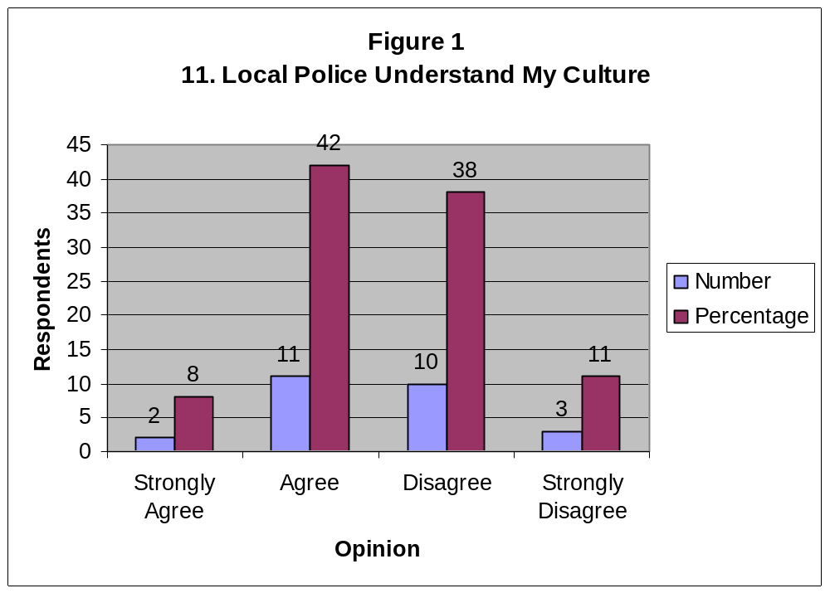

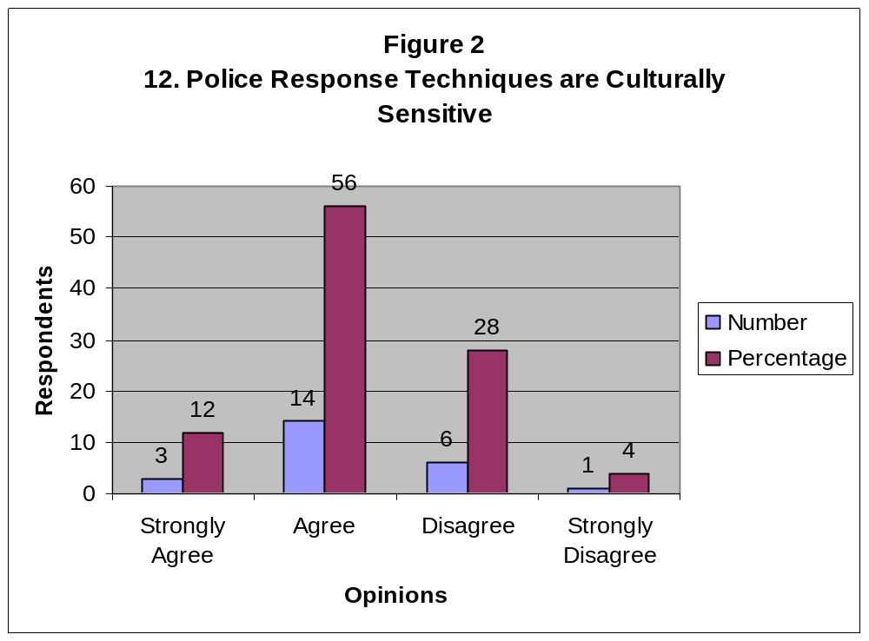

APPENDIX C
Remove

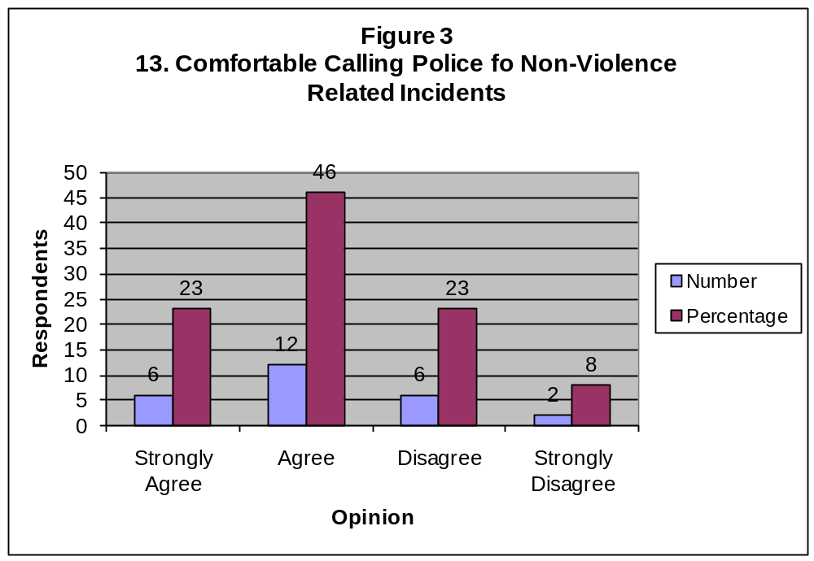

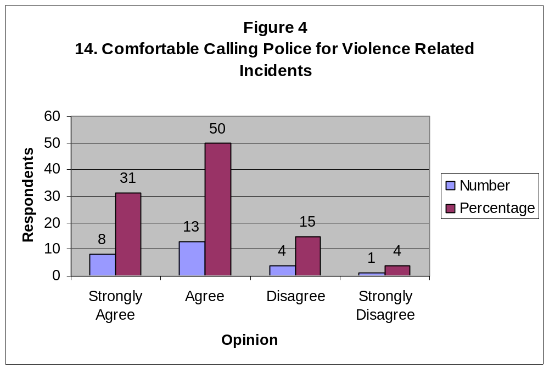

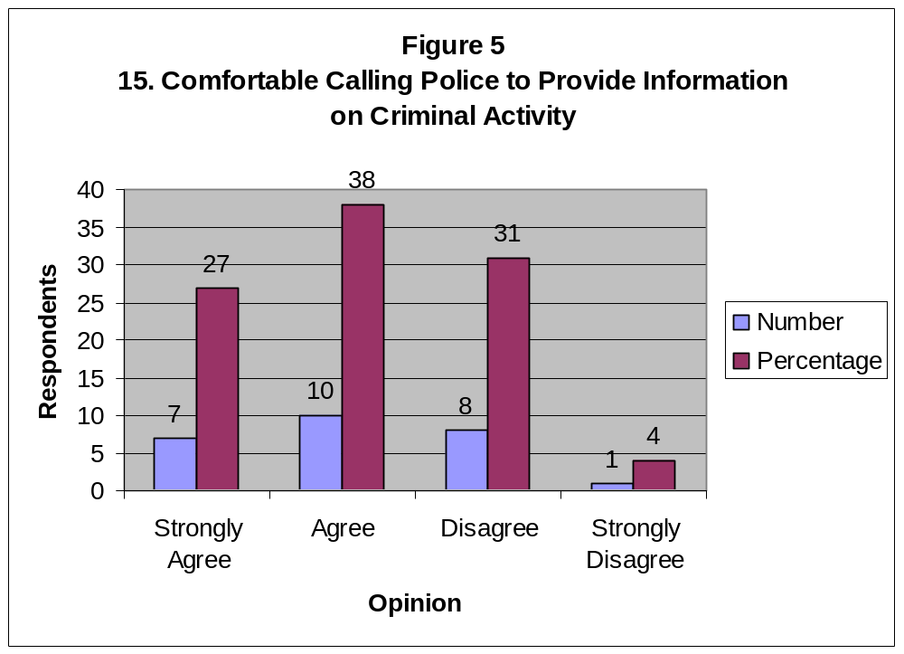

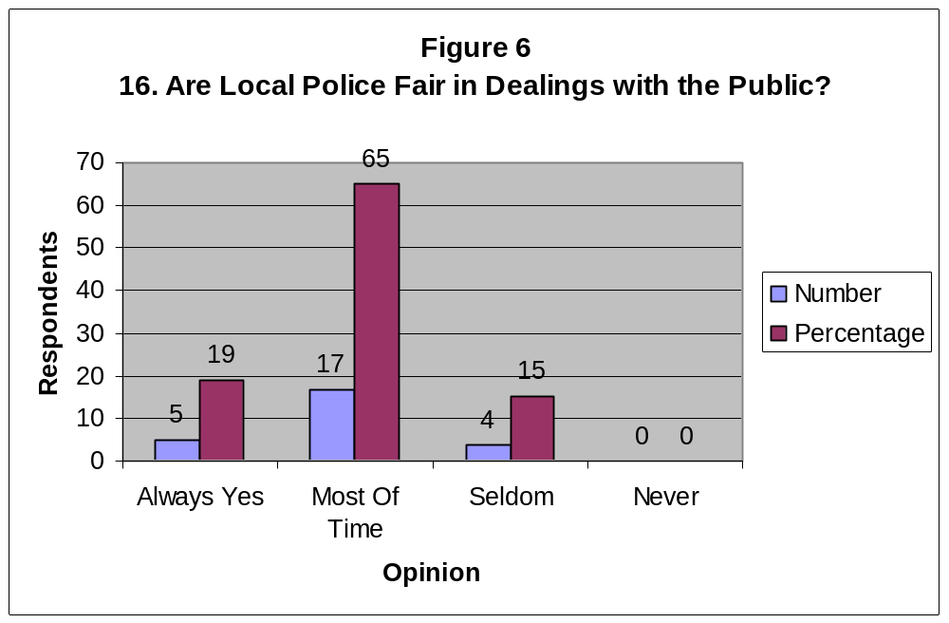

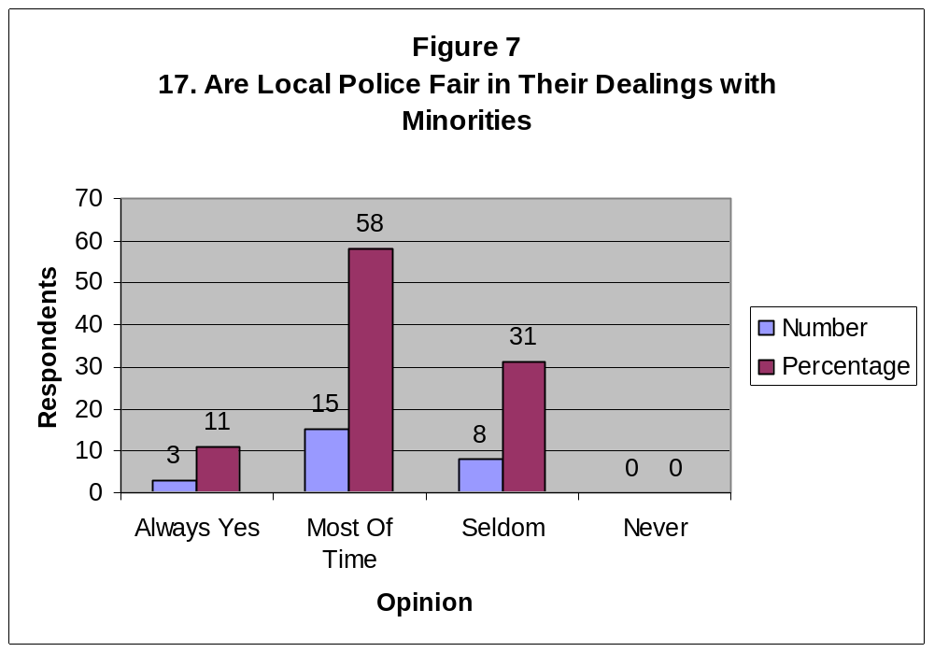

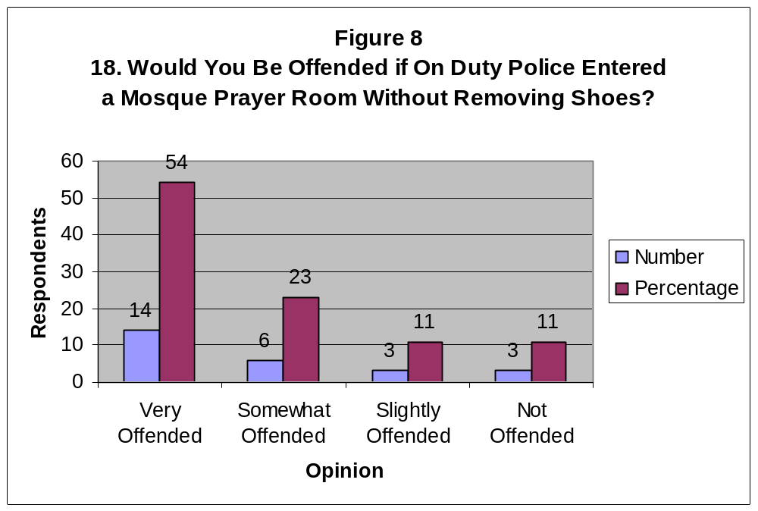

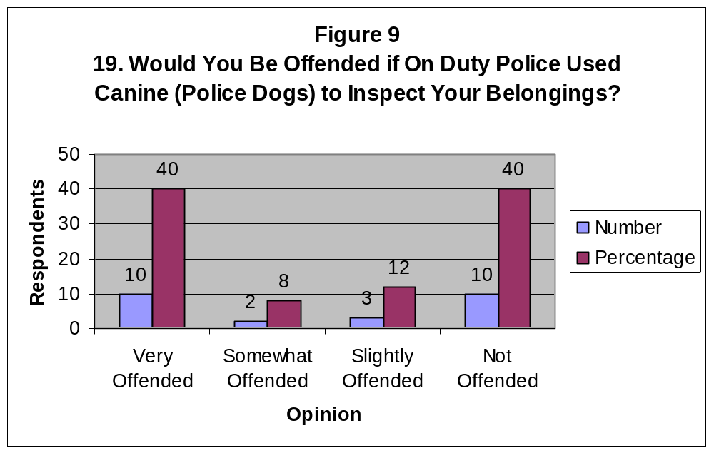

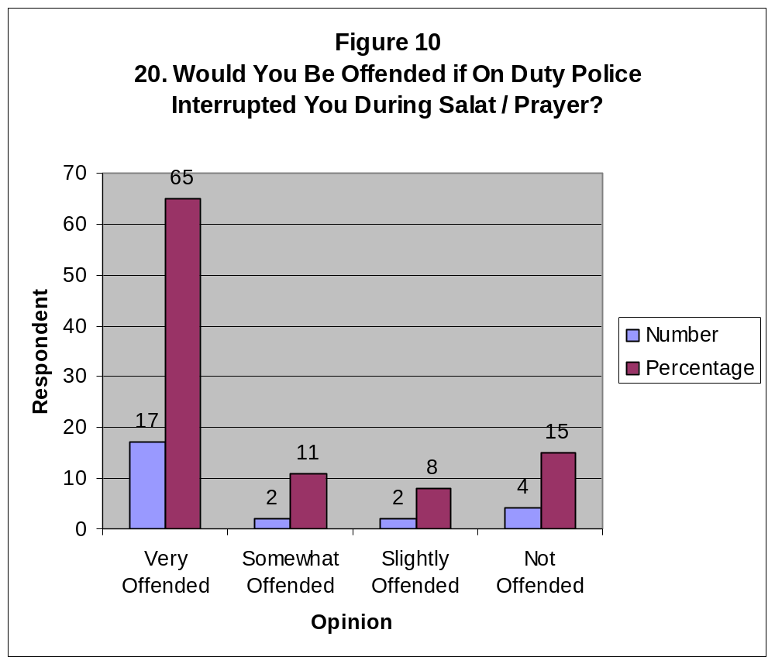

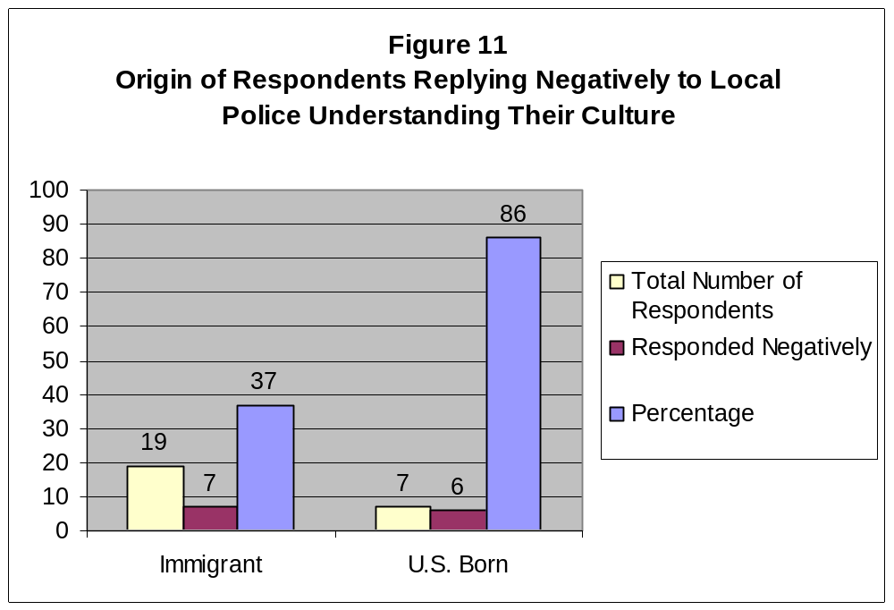

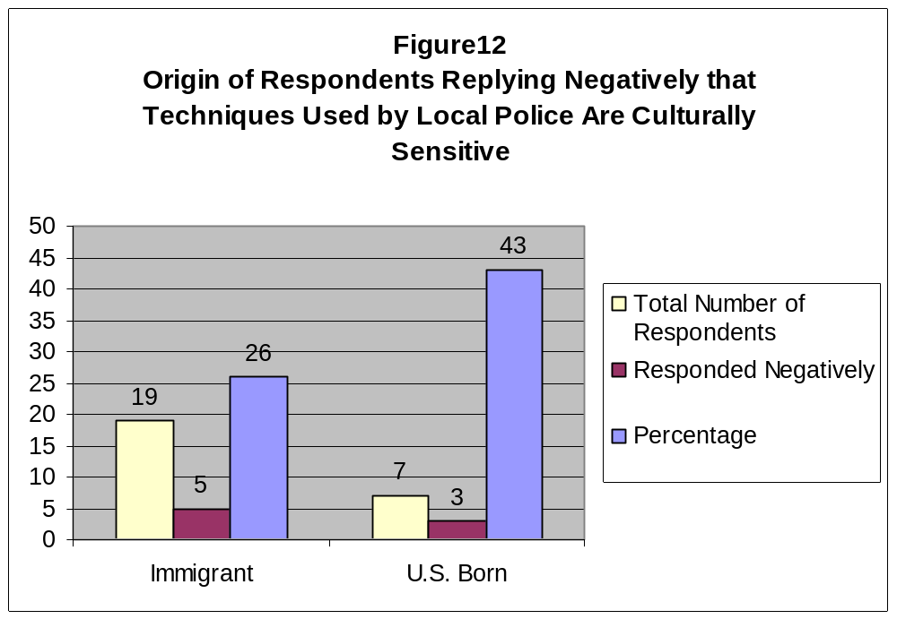

APPENDIX C



