Physics 427 Lab #9

DIGITAL GATE CIRCUITS

1. Combinational problems

For each of the following two problems, design a logic gate circuit and construct the circuit using any combination of AND, NAND, NOR, OR, NOT, XOR, or XNOR gates and verify that it works. If necessary, use paper tapes to label the input and output wires. For data inputs, you may use the data switches at the bottom of the breadboard. Use LED displays on the breadboards to monitor the data outputs.

Note: Currently (Fall 2025) some of the data switches are defect and are marked with ring labels. Use the LEDs to confirm that the data switches you are using are properly functioning. Do this when the switches are actually connected to your working circuit.

You should have a neat circuit diagram before actually constructing the circuit. Let the instructor see each circuit when it is functioning properly.

a) Chemical plant

Four large tanks at a chemical plant contain different liquids being heated. Liquid-level sensors are being used to detect whenever the level in tanks A and B rises above a predetermined level. Temperature sensors in tanks C and D detect when the temperature in these tanks drops below a prescribed temperature limit. Assume that the liquid-level sensor outputs A and B are LO when the level is satisfactory and HI when the level is too high. Also, the temperature-sensor outputs C and D are LO when the temperature is satisfactory and HI when the temperature is too low. Design a logic circuit that will detect whenever the level in tank A or B is too high at the same time that the temperature in either tank C or tank D is too low.

b) Seat belt

Design a circuit that will sound an alarm if a car’s ignition switch is turned on and if any one of the car’s passengers (including the driver) does not have their seat belt fastened. Each of the two seat belts (A and B) has a digital sensor that will be LO if the seat belt is not fastened and HI if it is fastened. Each of the two seats (C and D) has a weight sensor that is LO if no one is sitting in the seat and HI if someone is sitting in the seat. The ignition switch (E) has a sensor that is HI if the switch is on and LO if it is off.

2. Multiplexers

a) Basic MUX operation

Insert the 74251 Tri-state 8-channel MUX into the breadboard and connect it to + 5 volts (pin 16) and Ground (pin 8). Connect three of the data switches at the bottom of the breadboard to the data select pins of the 74251 (A, B, C – pins 11, 10, and 9, respectively). Connect the chip ENABLE (G – pin 7) to Ground (this ‘enables’ the chip). Apply a 500 Hz TTL signal from the function generator to the D0 data pin (pin 4). Monitor this TTL signal using CH1 of an oscilloscope. Connect CH2 of the oscilloscope to the chip output (Y – pin 5).

Use the data switches (on the bottom of the breadboard) to set the values of A, B, and C to zero (i.e., A = 0, B = 0, C = 0). According to the function table, these values of A, B, and C select the data from input D0 and send it to the output, Y. You should see the TTL square wave on the ‘scope. [The output from the MUX may have spikes (glitches). This is caused by the transistor switching taking place inside the chip and can be corrected by connecting a 0.01 μF capacitor directly between the + 5 V and Ground connections of the 74251.]

Connect the ENABLE to + 5 V and see what happens. Reconnect it to Ground. Connect the function generator signal to data input D1 and see if you can send that data to the output using the appropriate values of A, B, and C. Repeat for all of the other data inputs.

b) Using a MUX to implement a truth table

A MUX with three data selection lines and 2³ = 8 data inputs can be used to implement an arbitrary 3-input truth table. You will use the 74251 in this section to implement a 3-input XOR gate Y=A ⊕B⊕C, whose true table is given here:

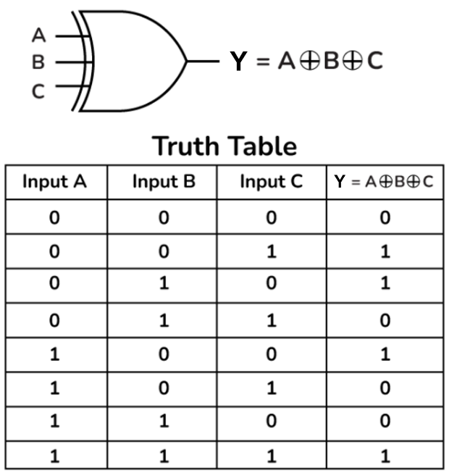

Disconnect the function generator from the 74251. By wiring certain data inputs to + 5 volts and the rest to Ground, create a circuit that emulates (acts exactly like) a 3-input XOR gate. The inputs are A, B, and C and the output is Y. Test the system to see if it behaves properly. Let the instructor see this when you have it working.
74LS251 multiplexer

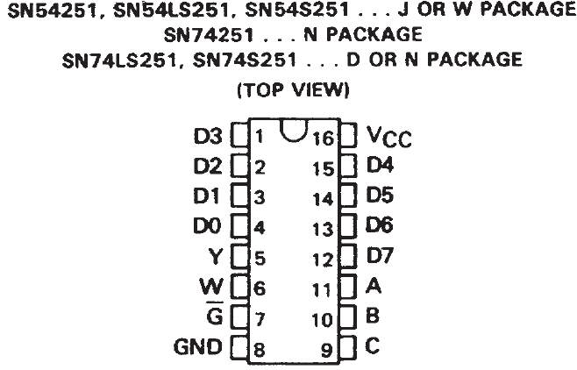

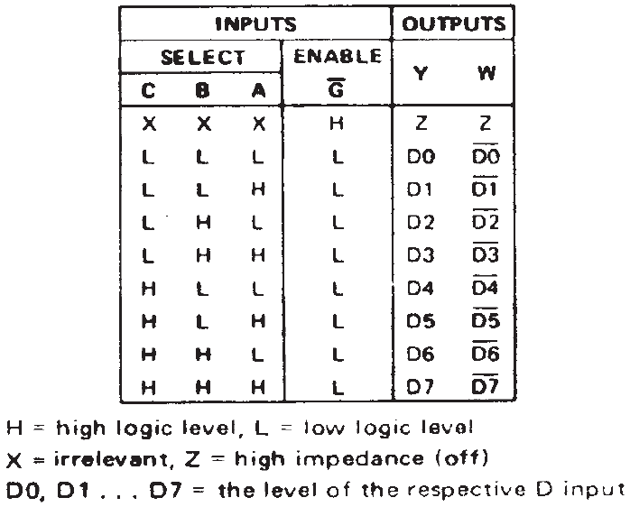

LAB REPORT Name __________________________

Physics 427 Lab #9

DIGITAL GATE CIRCUITS

1. Combinational problems

a) Chemical plant

Give the circuit diagram of the logic gate circuit you used to solve the Chemical Plant problem.

Give the Boolean algebra expression you used and explain how you found that expression.

b) Seat belt

Give the circuit diagram of the logic gate circuit you used to solve the Seat Belt problem.

Give the Boolean algebra expression you used and explain how you found that expression.

2. Multiplexers

a) Basic MUX operation

What happened when the chip enable (G) was brought HI? (Did data pass through to the output?)

b) Using a MUX to implement a truth table

Draw a circuit diagram showing how you made the 74251 emulate a 3-input XOR gate.

