Physics 427 Lab # 7

OP-AMPS II

1. Voltage follower

Construct the voltage follower shown below using OP-07. Verify that V_{out} = V_{in} for several input voltages. You may use the built-in ±5 V power supply combined with the 1 kΩ pot on the breadboard to provide a variable V_{in}.
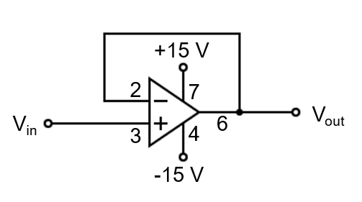
The major application of a voltage follower is as an impedance buffer. The input impedance of the follower is very large while its output impedance is very small. The following experiment will convince you of this.

Charge a 0.33 μF capacitor to 5 volts. (Use a high-quality capacitor - i.e., one that doesn’t have much leakage.) You might connect the capacitor using short cables with alligator clip ends and use momentary contact with a wire from the +5 V supply to charge the capacitor. Measure the voltage across the capacitor with a DMM. You should find that the voltage reading of the DMM decreases quickly with time. Determine approximately how long it takes for the voltage to decrease to 37% of its initial value.

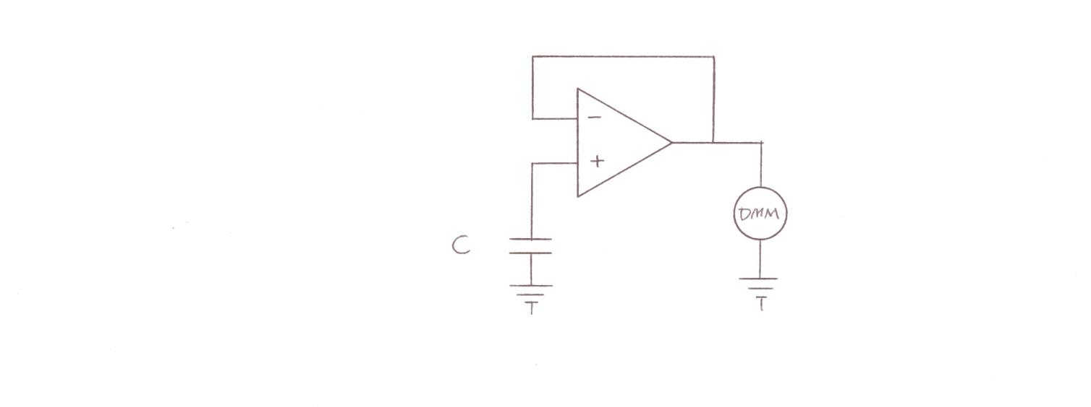
Now, as shown in the figure below, connect the capacitor between V_{in} of the follower (which you just built) and the ground, then momentarily touch the non-grounded end of the capacitor with a wire from the 5V supply, and measure the voltage at V_{out} using the same DMM you just used. What happens? Explain how the voltage follower has improved the measurement. Can you estimate the input impedance of the voltage follower? You could measure the output voltage at a given time and wait 2 or 3 minutes, then measure it again, and use the capacitor discharge equation to calculate the time constant, then calculate the input impedance (the R in RC) of the follower.
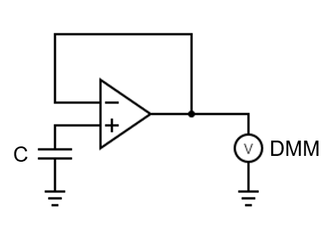
2. Summing amplifier

Construct the summing amplifier shown below. Use the following nominal resistance values: R_{F} = 10 kΩ, R₁ = 1 kΩ, R₂ = 10 kΩ. Be sure to measure the actual resistance and use them in all calculations. The output voltage for this amplifier will be given by:

V_{out} = – V₁(R_{F}/R₁) – V₂(R_{F}/R₂) = – (10V₁ + V₂)

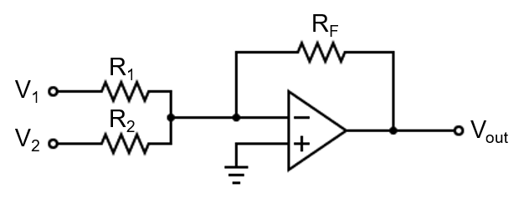
Connect frequency generator # 1 (FG1) to V₁ and frequency generator # 2 (FG2) to V₂. Using a DSO and set FG1 to produce a 2000 Hz sine wave with peak-to-peak voltage of about 200 mV (-20 dB in), and FG2 to produce a 200 Hz sine wave with peak-to-peak voltage 3 V (-20 dB out). Now use the DSO to measure the output waveform. You need some assistance from the instructor to show you how to trigger the oscilloscope. Take a picture of the output waveform. Is it equal to – (10V₁ + V₂)?

Observe the operation of the amplifier for a variety of input frequencies and amplitudes from FG1 and FG2. Does it perform properly?

3. Current-to-voltage converter

For the current-to-voltage converter shown below, the output voltage is given by

V_{out} = – (I_{in} )(R_{F}) + [ (I– )(R_{F}) ]

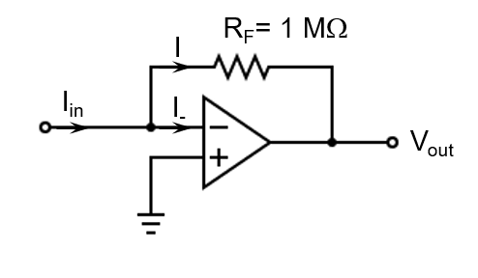
Note that the term enclosed in the square brackets is caused by the negative bias current of the op-amp. Let us call this term V₀ – the output voltage when the input current is zero.

V₀ = (I–)(R_{F})

For an ideal op-amp, this term would be zero. For our real op amp, it is non-zero. The current that we wish to measure is then given by the following equation:

I_{in} = (V₀ – V_{out})/R_{F}

You should first determine the value of V₀ for the OP-07 op-amp you are using. This is done as follows:

Allow the input terminal to float (i.e., don’t connect it to anything and don’t ground it) so that I_{in} = 0. Measure and record V_{out}. This will be equal to V₀.

Now use the current-to-voltage converter in the circuit shown below to measure the reverse leakage current of a signal diode (1N4004). To keep the potentiometer voltage positive, use a 5 V input on one side and ground the other side. Measure V_{out} using a DMM and calculate I_{in} for the following diode bias voltages: 0.0, 0.05, 0.10, 0.20, 0.30, 0.40, 0.50, 1.0, 2.0, 3.0, 4.0, 5.0 volts. The bias voltage is the voltage at the point where the potentiometer connects to the diode --- measure it using another DMM.

This circuit is very sensitive. Don’t disturb it during measurement. Make sure that the diode in the circuit is reverse-biased! The white stripe should be facing the potentiometer.

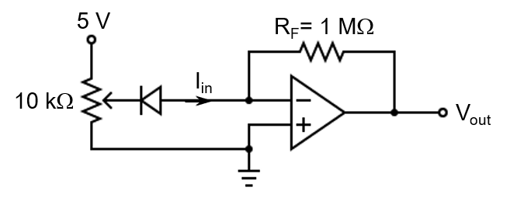

LAB REPORT Name __________________________

Physics 427 Lab # 7

OP-AMPS II

1. Voltage follower

How long did it take the capacitor to discharge to 37% (about 1/3) of its initial value when it was connected directly to the DMM?

How does this time compare with the RC time constant for the circuit? Is this consistent with an estimate of 10 MΩ for the R (input impedance) of the DMM?

What happened when the voltage follower was inserted between the charged capacitor and the DMM?

Explain why the voltage follower improved the measurement.

2. Summing amplifier

Attach a photo (or sketch below a picture) of the V_{out} waveform that you obtained for
V₁ ≈ 200 mV at 2000 Hz and V₂ = 3 V at 200 Hz.

Is the output waveform equal to V_{out} = – V₁(R_{F}/R₁) – V₂(R_{F}/R₂) = – (10V₁ + V₂) ?
If not, describe the differences.

Describe the change of the output waveform when you vary the frequencies and the amplitudes of the signals from FG1 and FG2.

3. Current-to-voltage converter

What was V₀ for your system?

Attach a graph of the diode reverse leakage current vs. bias voltage. Write down the ID# of the diode.

What was the resolution of your current-to-voltage measuring system (i.e., what was the smallest current that you could measure with the system?) Explain how you determined this. [Think carefully about the resolution of the DMM – what is the smallest voltage (or voltage change) that it can measure?]

