Physics 427 Lab # 6

OP-AMPS I

1. Non-inverting amplifier

Construct the circuit shown below on your breadboard. The OP-07 op-amp integrated circuit (IC) (see pin diagram below on the right) should straddle the center channel of the breadboard. Be careful when inserting the IC to ensure that the pins are not bent. When removing an IC, use the plastic tweezers provided. Do never use fingers to remove an IC. The numbers in the circuit diagram refer to the IC pin numbers. Note that the OP-07 is powered by voltages of +15 V and –15 V (referenced to ground) drawn from the power supply on the breadboard. Use R₁=R₂=100 kΩ. Note that Pin 4 is not connected to the right terminal of R₂.

[A “decoupling” or “bypass” capacitor may be connected from each power supply lead to the ground to increase the stability of the op-amp. Don’t use these unless you encounter stability problems. These capacitors can range from 0.1 μF to 10 μF. If you use electrolytic capacitors, be sure the polarity is correct.]

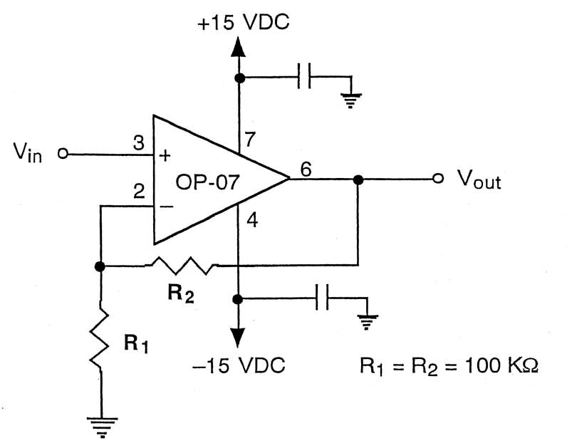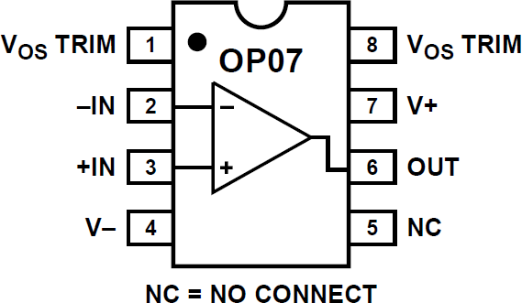

THE POWER SUPPLY SHOULD BE TURNED OFF WHEN YOU ARE CONSTRUCTING A CIRCUIT OR MAKING MAJOR CHANGES IN A CIRCUIT.

One rail of your breadboard should be connected to the +15 V output of the power supply, another rail to the -15 V output, and a third rail to the ground connection of the power supply. Remember that all DC voltage measurements made with the DMM must be referenced to ground (i.e., the common or black input connection of the DMM should be connected to ground).

Construct the voltage divider circuit shown below. It will be used to provide DC input voltage to the op amp. Connect point b of the potentiometer to V_{in} of the amplifier.
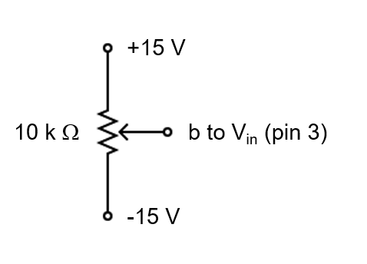
The gain of the amplifier you have constructed should be 2, as shown by the following:

GAIN = 1 + R₂/R₁ = 1 + 100KΩ/100KΩ = 1 + 1 = 2

Since V_{out} = GAIN x V_{in}, the output voltage should be two times the input voltage. In addition, the output voltage should have the same sign as the input voltage (i.e., if the input voltage is positive, the output voltage should be positive).

The actual gain of the amplifier will not be exactly 2, unless the resistors are exactly equal. You need to measure the actual resistances of R₁ and R₂ and calculate the true theoretical gain of the amplifier.

a) DC behavior

Use the potentiometer to apply a variety of DC voltages to V_{in}. Use at least 20 input voltages evenly spaced between +10.0 and –10.0 Volts. [Note: Don’t change the power supply settings. Simply turn the potentiometer dial to change the input voltages.] Measure both V_{out} and V_{in} with two DMMs (the oscilloscope is not accurate enough) and calculate the measured gain (GAIN = V_{out}/V_{in}). Does the measured gain agree with the theoretical gain (1+R₂/R₁)? (Be sure to use the measured values of R₂ and R₁ in this calculation.)

What are the maximum positive and negative output voltages that can be attained?

Select R₁ and R₂ values to give a gain of about 5.0. Be sure that R₁ is greater than or equal to 1 kΩ and that R₂ is no larger than 1 MΩ. Measure the gain of the amplifier (you only need to use a single V_{in} setting for this. Make sure that V_{out} is not saturated). How close is the measured gain to the theoretical gain?

Repeat for a gain of about 101 by selecting proper R₁ and R₂ values. Adjust the potentiometer carefully to set |V_{in}| < 0.10 V. V_{out} may contain a certain amount of noise. This is normal for a high gain amplifier.

b) AC behavior

Now, we will see how the amplifier responds to AC voltages. As shown in the circuit below, connect the function generator to V_{in}, and use the DSO to measure V_{in} and V_{out} simultaneously. You do not need to totally rebuild the op-amp circuit, just disconnect the input that previously came from the potentiometer and change the resistors. Use R₂ = 100 kΩ and R₁ = 10 kΩ. What is the theoretical gain of this amplifier?

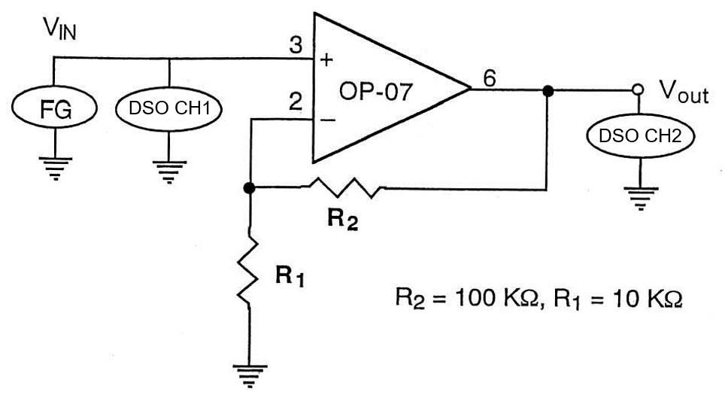

[Note that, although the power supply connections are not shown in the above circuit, they surely still need to be made.]

Set the FG to produce a 200 Hz sine wave. The -20dB button should be in the in position. In this case the FG provides up to ~ 2 V peak-to-peak waves.

Set the amplitude of the FG V_{in} to about 200 millivolts peak-to-peak (all AC amplitudes in this section will be measured peak-to-peak). What is the amplitude of V_{out}? Is the AC gain of the circuit the same as the DC gain?

Use at least 10 input voltages with peak-to-peak amplitudes spaced evenly between 0.2 and 2.0 volts and see if the gain remains constant.

How does the phase of V_{out} compare to that of V_{in}?

Now minimize the output of the FG. Set the -20dB button of the FG in the out position. In this case the FG provides at least ~ 2 V peak-to-peak waves. Increase V_{in} slowly until V_{out} begins to distort. Take a photo of the distorted waves. At what V_{out} values (positive and negative) does the distortion first start to appear?

LAB REPORT Name __________________________

Physics 427 Lab # 6

OP-AMPS I

1. Non-inverting amplifier

a) DC behavior

i) Gain =2

Record the measured resistances: R₁ = , R₂ = .

Calculate the theoretical gain of the amplifier:

Attach a graph of V_{out} vs. V_{in}.
For what range of the input voltages is the amplifier response linear?

Attach a graph of the amplifier gain vs. V_{in} across the linear region.
Does the measured gain agree with the theoretical gain?

ii) Gain ≈ 5

Record the measured resistances: R₁ = , R₂ = .

Calculate the theoretical gain of the amplifier:

Measured gain of the amplifier:

iii) Gain ≈ 101

Record the measured resistances: R₁ = , R₂ = .

Calculate the theoretical gain of the amplifier:

Measured gain of the amplifier:

b) AC behavior

Record the measured resistances: R₁ = , R₂ = .

Calculate the theoretical gain of the amplifier:

Attach a graph of V_{out} vs. V_{in}.
For what range of the input voltages is the amplifier response linear?

Attach a graph of the amplifier gain vs. V_{in} across the linear region.
Does the measured gain agree with the theoretical gain?

How does the phase of V_{out} compare to that of V_{in}?

Attach a photograph of the output voltage with distortion. At what V_{out} values (positive and negative) does the distortion first start to appear? What caused the distortion?

