Physics 427 Lab #5

TRANSISTORS

1. Current gain of an NPN transistor

In this lab, you will learn some of the characteristics of an NPN bipolar transistor, the 2N2222. Construct the following circuit, using a 1 MΩ potentiometer and R₁ = 10 kΩ, R₂ = 10 kΩ. The load resistance should be R_{L} = 1 kΩ. The supply voltage V_{CC} = 12 V is taken from the variable positive voltage (0 – 15V) on the breadboard.

Vary the potentiometer to get a set of values for base current I_{B} (starting at about 1 μA), and measure the collector current I_{C}. Record these in a table with three columns, for I_{B}, I_{C}, and the ratio β = I_{C} / I_{B}, which is known as the “beta”, or current gain of the transistor. Look for a saturation current I_{C}, which can be thought of as having the transistor in a conductive mode, hence the current approaches I_{sat} = V_{CC} / R_{L}.

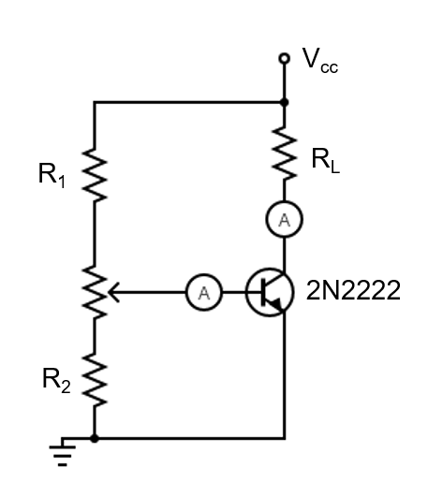

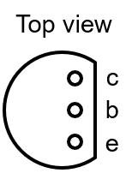

2. Switch

To demonstrate the switching behavior, construct the following circuit, using a 10 V (peak-to-peak) square wave from an FG as V_{in}. This square wave goes through a current-limiting resistor R_{B} = 10 kΩ to control the base current I_{B}. This will switch the output current on and off, so we will observe this directly using a light-emitting diode (LED), which should be in series with a load resistor of R_{L} = 1 kΩ to limit the output current and protect both the diode and transistor. Use a DMM to measure the base-emitter voltage V_{BE} and the collector-emitter voltage V_{CE}. The emitter is grounded in this circuit, so use the DMM common to attach to that point. You will need to reduce the frequency to be about 0.5 Hz to see the voltages switching.

Alternatively, instead of using the FG, you may manually attach and detach the V_{in} to the 5 V supply to simulate the input pulses.

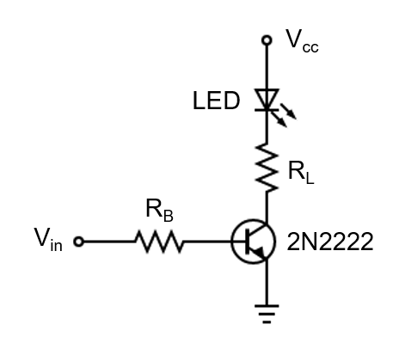

3. Emitter follower

To get voltage gain on the output, rather than just use the varying current, we need a resistor between the transistor and the ground (or the V_{CC}, as in the first circuit). Construct the following circuit. For V_{in} use a 5 V (p-p) 1 kHz sine wave from an FG, centered at zero (i.e., no bias added). Use R_{B} = 10 kΩ and R_{L} = 1 kΩ. Look at the input and output voltages using CH1 and CH2 of a DSO. Take a photo of the waveforms. Describe the signals. Try reducing the p-p voltage. Try using a square wave, and see if the rise time of the output is different from the input. Take a photo of the waveforms.

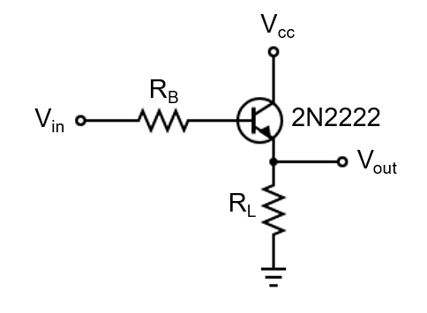

4. Common emitter (AC voltage amplifier)

To get a better response for small signals, it is best to use voltages in the middle of the active region of the transistor characteristic. This is done by using voltage dividers as in the following circuit. For the input signal V_{in}, use from 0.2 V to about 1.0 V (p-p) sine wave, at frequencies from 1 kHz to about 1 MHz. The FG may need a 50 Ω BNC terminator to prevent signal reflections. Use resistances and capacitances at approximately the labeled values. Record and plot the voltage gain A (using the peak-to-peak measurements on CH1 and CH2 of the DSO). Do this for at least two different frequencies.

If you have time, measure the phase shift in the output for a few frequencies (in different gain regions). Notice any distortion in the signal.

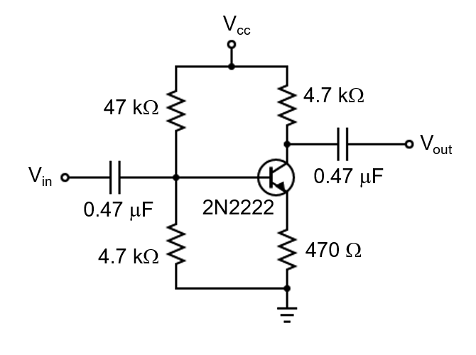

LAB REPORT Name __________________________

Physics 427 Lab #5

TRANSISTORS

1. Current gain of an NPN transistor

Attach the graph of the current gain β as a function of I_{B}.
What is the saturation current I_{sat}? Compare it with V_{CC} / R_{L}.

2. Switch

What are V_{BE} and V_{CE} when the LED is on?

What are V_{BE} and V_{CE} when the LED is off?

3. Emitter follower

Attach a photo of the input and output sine waveforms.
What is the difference between the peak voltages of the input and output waveforms?

Attach a photo of the input and output square waves, with the rise time resolved.

4. Common emitter (AC voltage amplifier)

Attach the graph of the voltage gain A as a function of the p-p voltage of the input wave. Do this for at least two different frequencies.

