Physics 427 Lab # 4

POWER SUPPLIES

1. Transformer

In this lab, you will use a transformer to generate a roughly 6 Volt (rms) AC signal, from which you will obtain various approximations to a constant DC voltage. While the transformer steps down the 110 Volt line voltage, the output can supply large currents. We are lucky to have some antique Sargent-Welch transformers in our lab. Currently there is no fuse installed on the transformer, so be careful not to short its output. For each part of this lab, be sure to wire and check your circuit before plugging the transformer in.

One advantage of using a transformer (beyond the obvious reduction in voltage and, thus, providing more safety) is that while the primary voltage oscillates relative to ground potential, the secondary can “float” to any necessary level (within the limits of insulation used inside the transformer). This is a useful feature for the measurements you will make on the “diode bridge” circuits used below. Note that when you measure a voltage signal using an oscilloscope, you are grounding a point in the circuit. You need to think before doing this: you may alter the functioning of the circuit significantly and you could also cause large currents to flow through circuit elements thus generating a characteristic odor and smoke!

Use a DMM to measure the rms output voltage of the transformer. Estimate the peak value of the voltage. Then use CH1 of the oscilloscope to measure the output waveform of the transformer. Note the frequency and amplitude. Does the peak value agree with your DMM measurement?

2. Half wave rectifier

Construct the following half wave rectifier circuit. Where a diode (1N4004) is used to block half of the AC waveform. Use R_{L} = 1 kΩ. Use CH2 of the oscilloscope to measure the output waveform of the circuit, while CH1 is measuring the output of the transformer, or the input for the diode. Can you compute the average, or DC, voltage of the output waveform of the circuit? Is what you see consistent with part 1 and with the diode curves you measured in a previous lab? Take a photo of the waveforms.
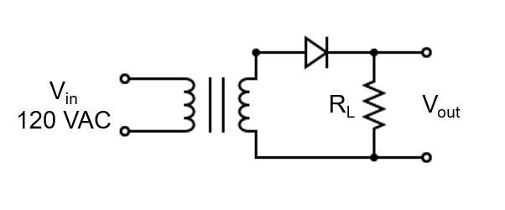

3. Full wave rectifier

The diode “bridge” (RS207L) circuit shown below directs current always in the same direction through the load resistor. Construct the circuit (without the capacitor C_{f}) and observe the output waveform using CH2 of the DSO. Use R_{L} = 1 kΩ. Disconnect CH1 of the DSO because the two channels of the DSO have a common ground. When you are measuring V_{out} using CH2, your action already defines the bottom line of the diagram as the ground. In this case, CH1 can only be used to measure the voltage between a point and the ground you just defined.

What is the average voltage? Take a photo of the waveform you observed.

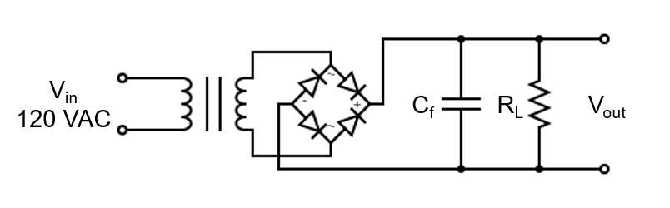

4. Full wave rectifier with filtering

To smooth the output and better approximate a constant voltage, place a capacitor across the output as shown in the diagram above. What is the relevant quantity which determines how “constant” the voltage is? What resistance combines with the capacitance to set the characteristic time of this low-pass filter? Do you want a small or a large capacitor? Why? Try C_{f} = 4.7 μF, and then a 47 μF electrolytic capacitor (or capacitors of similar size). Be sure to observe the polarity on the electrolytic capacitor. In each case, take photos, and measure the ripple voltage (peak-to-peak fluctuation).

Now use the C_{f} = 47 μF capacitor. How does the DC voltage vary with load – i.e., characterize the “voltage regulation” by trying a different load resistor? Calculate the power before you make the substitution to be sure the resistor can handle the power. Our most common resistors have a power rating of ¼ W or ½ W.

5. Integrated circuit regulator

One way to make a DC supply for real circuits is to build a rudimentary DC supply, such as the one shown below, and then use an integrated circuit (IC) “voltage regulator” to stabilize it. Construct the circuit shown below using an LM7805 IC, which is a 5 V supply regulator. See spec sheets (or search “LM7805 pinout”) for connections. We use this IC as a “black box” and just empirically note the quality of performance. Use C_{f} = 47 μF and R_{L} = 1 kΩ.

Use CH2 of the DSO to measure the V_{out} of the circuit, while CH1 is measuring the input of the 7805 IC. Also use a DMM to measure the V_{out}. Take a photo of the waveforms.

How does the DC voltage vary with the load? Calculate the power before you make the substitution to be sure the resistor can handle the power.

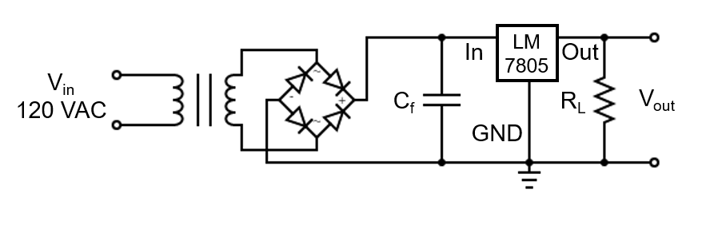

LAB REPORT Name __________________________

Physics 427 Lab #4

POWER SUPPLIES

1. Transformer

What is the rms voltage of the output of the transformer measured by the DMM?

Estimate the peak value of the voltage.

Attach a photo of the output waveform of the transformer. What are the frequency and amplitude of the waveform? Does the peak value agree with your DMM measurement?

2. Half wave rectifier

Attach a photo of the waveforms of the output of the transformer and the output of the circuit (both shown in the same picture). Calculate the average voltage of the output of the circuit.

3. Full wave rectifier

Attach a photo of the output waveform of the circuit. Calculate the average voltage.

Explain why we cannot simultaneously measure the output waveform of the transformer using CH1 of the DSO while we are using CH2 measuring the V_{out} of the circuit.

4. Full wave rectifier with filtering

According to your opinion, what is a “constant” voltage?

What resistance combines with the capacitance to set the characteristic time of this low-pass filter? Do you want a small or a large capacitor? Why?

For each capacitor you use, attach a photo of the output waveform. What are the ripple voltages?

List the output DC voltages at several different load resistances.

5. Integrated circuit regulator

Attach a photo of the waveforms of the V_{out} of the circuit, shown together with the input of the 7805 IC. What is the V_{out} measured by the DMM?

List the output DC voltages at several different load resistances.

