Physics 427 Lab # 3

RC FILTERS

1. Low pass filter

Construct the low pass RC filter shown below using a 10 kΩ resistor and a 0.1 μF capacitor. Be sure to make the ground connection properly. Notice that both channels of the oscilloscope are being used, one for the input to the filter, and one for the output.

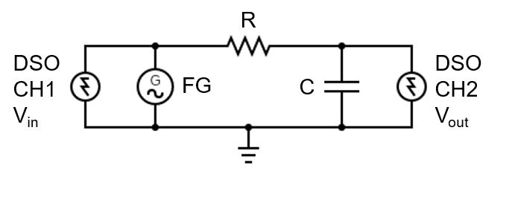
Using the oscilloscope, determine the ratio of the peak-to-peak amplitudes of the input and output voltages V_{out}/V_{in} at each frequency listed below. You can measure these easily using the measure function and setting up measurements of CH1 peak-to-peak voltage and CH2 peak-to-peak voltage. You may be able to set the function generator to a p-p value of 10.0 V (as measured by the oscilloscope) to make the estimations or calculations easier later. Record your data in an Excel spreadsheet.

As you do these measurements, also measure the phase difference between V_{out} and V_{in} for each frequency. You can do this by measuring the time difference between zero crossings (or the crests) for the two signals, using the CURSOR function and recording the delta reading from the screen, then multiply by the frequency (which is the same as dividing by the period) and multiplying by 360º. That is, φ = (Δt) x f x 360°. Note Δt has a sign convention, where time lag is thought to be negative.

Use approximately the following function generator sine wave frequencies: 20, 40, 80, 100, 140, 160, 200, 400, 800, 2000, 4000, and 8000 Hz. Record the actual frequency that you used (from the function generator, or measured by the oscilloscope --- they should be very close to each other).

Set the FG to a frequency of 1000 Hz and use the FG DC offset control to add a DC offset to V_{in}. Make the offset both positive and negative. Does V_{out} behave as you would expect for this filter?

2. High pass filter

Construct the high pass filter shown below. Note that compared to the low pass filter the positions of R and C have been switched. Also, we now use a 1 kΩ resistor and a 0.1 μF capacitor.
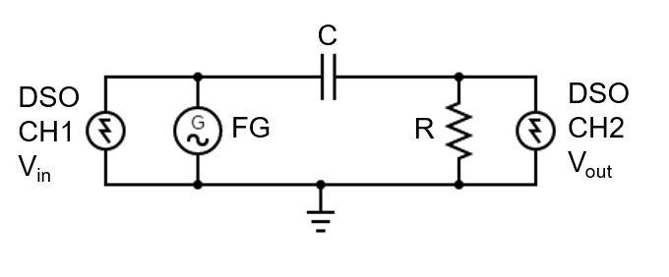
Using the oscilloscope, determine the ratio of the peak-to-peak amplitudes of the input and output voltages V_{out}/V_{in} as you did for the low pass filter. As you do these measurements, also measure the phase difference between V_{out} and V_{in} for each frequency.

Use approximately the following function generator sine wave frequencies: 40, 80, 200, 400, 800, 1600, 1800, 2000, 4000, 8000, 20000, 40000, and 80000 Hz.

Set the FG to a frequency of 1000 Hz and use the FG DC offset control to add a DC offset to V_{in}. Make the offset both positive and negative. Does V_{out} behave as you would expect for this filter?

LAB REPORT Name __________________________

Physics 427 Lab # 3

RC FILTERS

1. Low pass filter

Calculate the breakpoint (cutoff) frequency using f_{B} = 1/(2πRC).

Plot the frequency response of the filter using a log-log scale and attach it to this report. [i.e., plot log₁₀(V_{out}/V_{in}) versus log₁₀(f)].

Does your plot have the characteristics of a first order filter plot (i.e., cutoff frequency gives a -3 dB point and the slope on log-log plot is -1)? Show these features on your graph, and indicate how you calculated the slope of the plot in the attenuation region.

Attach a plot of the phase difference between V_{out} and V_{in} versus log₁₀(f). Does this plot agree with theoretical predictions?

2. High pass filter

Calculate the breakpoint (cutoff) frequency using f_{B} = 1/(2πRC) .

Plot the frequency response of the filter using a log-log scale and attach it to this report. [i.e., plot log₁₀(V_{out}/V_{in}) versus log₁₀(f)].

Does your plot have the characteristics of a first order filter plot (i.e., cutoff frequency gives a -3 dB point and the slope on log-log paper is +1)? Show these features on your graph, and indicate how you calculated the slope of the plot in the attenuation region.

Attach a plot of the phase difference between V_{out} and V_{in} versus log₁₀(f). Does this plot agree with theoretical predictions?

