Physics 427 Lab # 1

DC CIRCUITS

1. Voltage divider

Using the simple breadboard, construct the voltage divider circuit shown below. The
“+” terminal of the power supply should be connected to one of the “rails” of the breadboard and the “–” terminal to another rail. Notice that the rails have red and black (or blue) lines next to them, with black used to indicate “ground” and red indicating “hot” or “positive”.
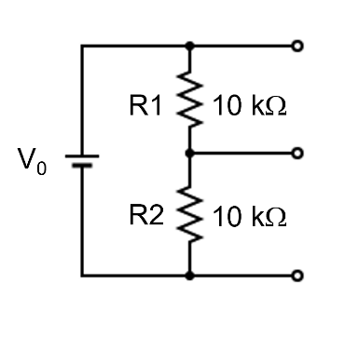
Since the nominal value of a resistor will always differ from its true resistance, be sure to measure the resistances R1 and R2 using the DMM as an ohmmeter. This measurement should be done with the resistor disconnected from the circuit. Enter these values in the data table in your lab report sheet.

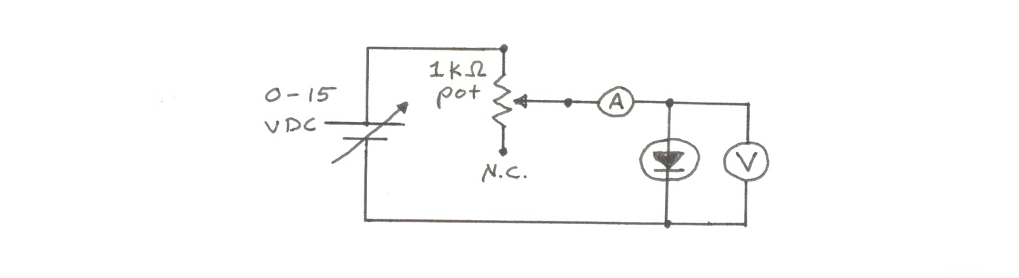
a) Use the DMM as a voltmeter to measure the power supply voltage V₀ (use 5.00 V unless instructed otherwise), the voltage V1 across R1, and the voltage V2 across R2. Do these measured values agree with the theoretical predictions for this circuit? The DMM has an internal resistance of 10 MΩ. Why don’t you need to worry about the effect of this internal resistance on the circuit?

b) Connect a 1 MΩ resistor in parallel with R2 (this is called a “load” resistor) and measure the voltage across R2. Is the voltage divider being loaded by the 1 MΩ resistor? Compare your measured values with the theoretical predictions.

c) Repeat (b) using a 100 kΩ load resistor.

d) Repeat (b) using a 10 kΩ load resistor.

e) Repeat (b) using a 1 kΩ load resistor.

2. Variable resistor

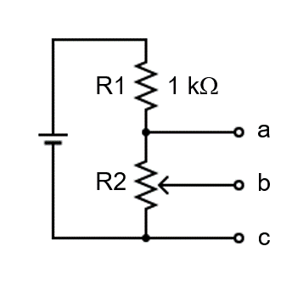
Using a DMM as an ohmmeter, identify which terminal of the potentiometer (“pot”) is associated with the movable node b. Label the terminals so that a clockwise rotation of the shaft (when viewed against the end of the shaft) moves b from c toward a (so that the resistance across b and c is increasing).

Then use the 1 kΩ pot and a 1 kΩ resistor to construct the voltage divider circuit shown above, using the constant 5 V power source.

Use a DMM to measure the voltage between points b and c (V_{bc}). Verify that by turning the knob of the pot you can obtain any voltage between 0 and 2.5 V.

3. Diode I-V characteristics

Our goal is to determine the current through a diode in the forward (and then reverse) direction at various applied voltages, using the circuit shown below. The exercise above tells us the pot can be used to limit the voltage and current through the diode. However, you need to be careful when you turn it close to its upper limit. Use a constant power supply voltage of 15 V, unless otherwise instructed. Use the pot to change the voltage on the diode. In each measurement, always start with the minimum voltage on the diode by turning the pot to its lower limit. You will need to use one DMM for the current measurement and a second DMM for the voltage measurement. Don’t exceed 10 mA for the forward measurement. Make an Excel table to record your measured values of V and I. You need more data points when the current I is changing quickly. This will be plotted later.

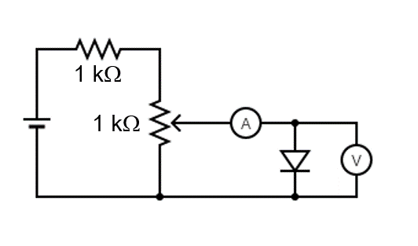

Reverse the diode and take data for the reverse direction. You may need the μA range for measuring the current. Don’t exceed 5 V for the reverse measurement. Record V and I with a negative sign.

Repeat this for a red LED. The forward direction will be obvious when you have it hooked up correctly and see the emitted red light. Don’t exceed 10 mA for the forward measurement. Don’t exceed 5 V for the reverse measurement.

Now do this again for a Zener diode. Don’t exceed 10 mA for the forward measurement. The reverse characteristic will have to be cut off just above the Zener voltage when the current exceeds about 10 mA.

Record the identification numbers of the diode and the Zener diode you are using.

LAB REPORT Name __________________________

Physics 427 Lab # 1

DC CIRCUITS

1. Voltage divider

Fill in the following table with your theoretical calculations and measured data.
Nominal values of R1 and R2 are 10 kΩ each, and the measured values are:

R1 = _____________ R2 = _____________ V₀ = _____________

R_{load}  (nominal) | R_{load}  (measured) | V1  (theory) | V1  (measured) | V2  (theory) | V2  (measured)
infinite | infinite
1 MΩ
100 kΩ
10 kΩ
1 kΩ

Show your calculations (in the space below) for the case with the 1 kΩ load resistor.

For which of the load resistances in the table is the “loading” significant (i.e., V1 and V2 differ by more than 10% from the “no load” values)?

Are the cases where significant loading occurs the ones that are predicted by the “10x” rule-of-thumb (i.e., significant loading occurs if the load resistance is less than or equal to 10 times R2)?

Why doesn’t the DMM (internal resistance = 10 MΩ) cause any loading in the above measurements? Or does it cause loading that was not taken into account?

2. Variable resistor

How much power does this variable resistor dissipate? Show your work below.

With no load resistor connected between nodes b and c, does this power depend on the position of the knob?

3. Diode I-V characteristics

Using Excel, plot I vs. V for both the forward and reverse directions of each diode in one plot. You therefore have 3 plots. Attach the plots to this report. Your plot should be similar to Fig. 3.12 in the text. It should fill most of the page, have proper labels and axes, and indicate the scale or units of the measurements. Include the Excel data sheet for each plot (this practice should be kept throughout the semester). Write the identification numbers of the diode and the Zener diode on your plots.

