ENGR 345: Lean Project Management Problem
Project Intent
Lean is a business strategy to not only eliminate waste, but to achieve a future state. However, successful companies realize they do not achieve a future state without involving everyone in the transformation process. You represent a leadership team now. This project should reveal differences in knowledge and skill sets, challenges in determining roles, challenges in applying knowledge and skills, and the importance of engaging in a process. There are always challenges in working with teams, and this project will likely reveal who are positive contributors and who are deadwood. However, the true intent of this project is to put you in a real-world setting where you are forced to make tough decisions. There will be much variance in this project; because of this, one of the larger goals is to see improvement strategies from differing points of view. Most importantly, this project should also help you determine what you need to learn about more.

The Company: ABC Storage
You represent a management team for ABC Storage Company, who as of late, is experiencing some stress in sales due to a slumping economy and increased overseas competition. ABC Storage specializes in constructing panel sided sheds. About 80% of the customer base is contractors and 20% individual consumers that are reached through local improvement stores (e.g. Lowes, Home Depot, Menards, Carter). Once sheds are constructed, they are shipped by a flatbed to the customer. The end customer is responsible for any coating (painting, staining, etc.) operations; the customer wants the flexibility to match any color. Still, with a panel design, the customer is still able to apply vinyl siding over the shed, and most times, the customer knows this up front. Sheds sell between $1800-$2400 each.
The small company runs on one 8.5 hour shift, with a paid 30 minute lunch break and two paid 15 minute day breaks. While the company generates about 1.3 million in sales per year, workers are typically paid low wages ($10-12 hour) to make a profit. Many times, overtime is necessary to meet the schedule. Schedules drive production at ABC, and managers scramble to get parts to workers and products out the door. Lead times for sheds is about 6 weeks. Upper management sees this as a problem, and as a result, is considering hiring more management/supervision.

The Facility
The ABC facility is rather simple. At the present, the large building is divided into three parts, 1/4 being the office area, and 1/4 production, and 1/2 storage for parts, WIP, Rework and defects, maintenance, and the central tool storage area. The production area of the facility can house up to 10 of the large sheds. Pneumatic and electrical drops are throughout the building.
Because there is a large storage area at ABC, all materials including lumber, nails, windows, panel siding, doors, and shingles are forecasted and ordered in advance. Suppliers deliver regular weekly shipments of all materials, and those materials go right to warehouse storage. Sometimes orders fluctuate, so more inventory is carried, and on occasion, there are shortages because of mistakes made in the computer inventory management system. Normally orders are placed to suppliers once a week on a Wednesday, accurate or not. This really doesn't matter, because there is an overflow area in the warehouse.

Product Configurations
Size: [16 x 8 x 8], [12 x 8 x 8], and [10 x 8 x 8] (customer chooses one)
Side Window: One large 24 x 18 window, or one small 16 x 16 window (customer chooses one)
Stock Door on one end of shed: One stock 30" door (for all sheds)
Roller Door on opposite end of shed: One small 36" roller door, or one large 48" roller door (customer chooses one)

Demand
Monthly demand for sheds is fairly stable. From the past year of data, monthly demand can be figured with shed size as the primary distinguishing characteristic. An average of 60 sheds are produced each month with average frequencies as follows.
Monthly demand size: 36 L [16 x 8 x 8], 20 M [12 x 8 x 8], 4 S [10 x 8 x 8]
Monthly demand stock door: 60 doors
Monthly demand roller doors: 50 large roller doors, 10 small roller doors
Monthly demand windows: 30 large, 30 small

Process
All sheds go through the same process sequence. Each task is completed by specialist(s), so the specialist(s) rotates in the production area to perform work. Products are stationary in the facility, so when one task is finished, then the next operator/operators show up on-site and performs work. Finished products are moved to the shipping dock using a large fork truck. It is not uncommon to have to move several sheds to get to a finished shed. Sometimes there is confusion about which shed to work on next. People run into one another and get into each other's way, but this is accepted and work goes on. For each task, there are many measurements to be taken, and several cuts in order to complete work. Most of the time, trades have to inspect the status of work before starting their own task. However, occasionally a worker may go to start a task on a product only to find that a required operation hasn't been finished (e.g. roofing operator shows to work on the roof when the walls are not finished). Four things can happen: 1. They go to find the manager to determine what to work on next, 2. They look for work, 3. They make sure they look busy, or 4. They do the task anyway (sometimes causing other problems such as delays, defects, or safety problems). Since separate schedules exist, really, central has no idea if or when a project will be complete. They have to ask the production leader who has to check with the area supervisor who has to check with the trade workers.
Occasionally there are several delays along the way, but from initial observation, some tasks are sequenced while others are not. Estimated task times are recorded below. It is known that some trades are more efficient than others. There is setup time (usually 30%) due to trades having to clean up and setup (ladders, pneumatic tools, moving supplies) for their operations. Because there are no real standards, there are time differences. Sometimes workers stop mid-shift to get more parts or supplies, remove scrap, fix flaws, look for the manager to what needs to be worked on, to find tools, fix mistakes, or deal with other distractions. Some minor time differences come with model size as well (e.g. larger model sheds have more roof to put on than smaller sheds). Because foundations come in only 3 sizes, the company will often fabricate each of the models and store them in the warehouse until needed.

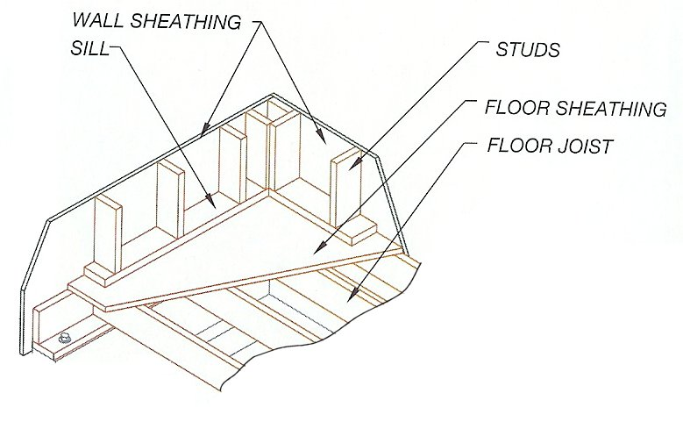
Estimated task times (including setup) are as follows:
1. Order processing
2. Foundation Construction (90-120 minutes, 2 operators)
3. Framing (120-150 minutes, 2 operators)
4. Panel Siding (120-150 minutes, 2 operators)
5. Roof (150-180 minutes, 2 operators, one delivering)
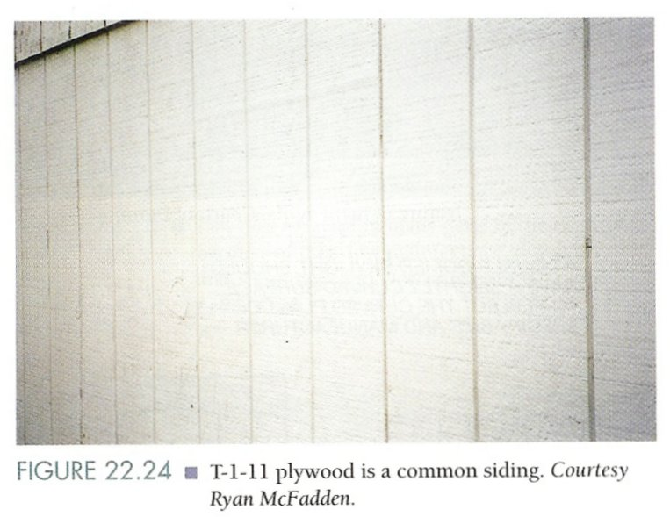
6. Side Window Installation (60-90 minutes, 1 operator)
7. Front End Roller Door Installation (90-120 minutes, 1 operator)
8. Back End Standard 30" door installation (60-90 minutes, 1 operator)
9. Fascia Installation (60-90 minutes, 1 operator)
10. Trim-work around windows and doors (60-90 minutes, 1 operator)
11. Ship to customer

Product Design
All framing is standard 2 x 4 construction, 24" on center
Standard preassembled trusses are mounted to the top plate using standard truss clips
Roofing is assembled to trusses using 2.5 inch nails
Floor joists are made up of treated 2 x 6 lumber with 3/4" treated plywood sheathing - Foundations are temporarily supported on skids to facilitate easy moving to the shipping dock by large fork trucks.
All walls are is 5/8" vertical panel siding which is assembled to 2 x 4 framing with staples
Individual pneumatic guns assemble 3" sixteen penny nails in foundation and framing operations
Individual staple guns are used to assemble 5/8" panel siding with 2" staples and 25-year shingles with 1 inch staples.
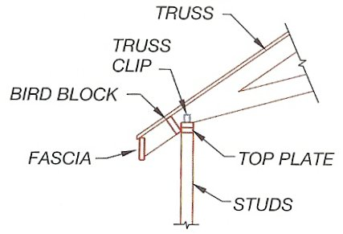
Fascia is constructed of standard treated 1 x 6 boards and assembled using 2" nails.
Trim work is standard 1 x 4 boards assembled with 2" staples

Problems
It goes without saying that ABC Storage suffers from various form of waste. Last year, there were two claims from people who were hurt from fork trucks retrieving sheds. Occasionally, fork trucks also cause damage resulting in rework operations. Sometimes tasks are missed. For instance, 11 sheds were shipped to the customer last year that did not have completed trim-work. Production delays are also very typical.

Your Task
1. This project is your calling, and to be successful, you will have to be very efficient. Quickly assemble in to teams of four. Recommendation: People with different backgrounds.
2. Establish a process for tackling this assignment. Draw a picture of your process upfront. Establish your goals and plan (timeline) for achieving objectives. Establish a project leader who will ensure the integrity of your process. Recommendation: Select someone who has a balance of motivation, is resourceful or experienced. The project leader will ensure input from everyone and help to maintain the process.
3. Determine product inputs (e.g. a BOM of parts in finished products). Construct the current state for operations (VSM - hand drawn is acceptable)- this should align all of you to what this company looks presently looks like. Construct the current state for layout (use CAD).
4. Can this company keep up with demand? Can we apply design principles to this example? If so, what and why? How do we know these will project savings? Where did you find your information? Can lean principles be applied to this example? What tools/mechanisms can be put into place to ensure flow of product and information (low level)? What do these mechanisms/tools look like? What systematic mechanisms/techniques ensure the sustaining of flow (high level)? Can you visually show or provide examples? What will you share with the company? What will this look like?
5. Construct a future state for operations (VSM - hand drawn is acceptable). Construct a 3-6 month future state for layout (use CAD). Indicate where your team would like to make sequential improvements. Construct an implementation plan (use MS Project) of for achieving future state. Be sure to list the various changes you seek or that are expected.
6. Indicate what you intend to monitor/measure to achieve the future state (these are your metrics).
7. The class is your company. As managers (leaders of the company), you are to construct an electronic presentation of your project for the class. This will detail the process you used as well as the project specifics. Justify your decisions. Indicate current state, future state, implementation plan, and what you intend to measure to indicate your level of achieving the future state. Be prepared to present this in 8-10 minutes to the class in the 15th week (everyone participates).
8. Deficiencies? Document what your team members need to learn more about in improving processes like this.
9. Fill out an evaluation of your team members. This will detail each individual’s role in the project and how they performed. Their total performance rating will be multiplied by points awarded for the project. Each member will also fill out an evaluation for themselves.

Evaluation (one from team member)
MEMBER NAME | PERFORMANCE RATING | RATIONALE
 | [Low] 1 2 3 4 5 [High]
 | [Low] 1 2 3 4 5 [High]
 | [Low] 1 2 3 4 5 [High]
 | [Low] 1 2 3 4 5 [High]

