How to Make Online Quizzes with Hot Potatoes

1. Download, install, run, and register the software.
Download: http://hotpot.uvic.ca/ - use Downloads. (The Windows version works well. I’d avoid the Java version for the time being.)
Install and Run: typical
Register: This is necessary to have more than 2 questions and to use other features. (Do this after you have downloaded and installed the software. You do this once.)
1. Go to the web site http://hotpot.uvic.ca/ and click Register.
2. Click read the license terms. (read the license terms)
3. Check the box for I have read the license agreement,
4. Fill out the form.
5. Open your e-mail and get the registration key (number).
6. Go to the Hot potatoes software. Click Help|Register and type in your name and registration key.
2. Make a quiz, save it as a .jqz file and save it as a web (.htm) page.
Run Hot Potatoes 6 or go directly to JQuiz. Question types: Multiple-choice, short-answer, hybrid, multi-select.
Filetypes (Under the File menu. Save creates .jqz; Create web page creates .htm)
- .jqz file – this is the file which you can edit in JQuiz.
- .htm file – this is the actual quiz which runs in the browser (IE, Firefox, etc.)
Special characters (e.g., ÷ ≈ ≠ ±) are available at Start|Programs|Accessories|System Tools|Character Map
3. Make a quiz with graphics.
1. Start a New Exercise (new quiz) and save the quiz file (as a .jqz file) or open an existing quiz file. We will assume the quiz file is stored in the Math206 folder.
[2. Create a folder (subdirectory) in the Math206 folder. Graphics is a good name for the folder. (You only need to do this step once.)]
3. Create your graphic (options included Word, some drawing program, Paint, Geometer's Sketchpad, etc.). Save the graphic in the Graphics folder (.gif and .jpg file types work well, but you can experiment with others)
4. In Hot Potatoes JQuiz, Insert|Picture|Picture from local file. (or click the button). (HTML code will be put in for you.)
5. Re-save your quiz file. Export as a (.htm) web page and view it in the browser to see your graphic!
4. Help, Online tutorials, support, and the Configuration Window.
*Help (in JQuiz) *Tutorials (on the hotpot web site) *Support (on the hotpot web site)
Configuration Window (Under the Options menu)
- Allows you to control many things from what is shown to the student, to colors, to directions, and more. (Has numerous tabs across the top.)
- Can type Exercise (quiz) directions or a subtitle.
- Under the "Other" tab you can
*Shuffle order of questions, *Shuffle order of answers, *Show number of questions answered correctly in one guess, *more.
- Under the "Buttons" tab you can
*Include the "Hint" button (or not), *Include the "Show answer" button (or not).
- Many other options (most of which are self-explanatory).
5. Upload your quiz to the Internet.
(Recommended Use of Folders and File Locations on the back)
Option 1: Upload to the hotpotatoes.net website (option is given when you create the web page)
Option 2: Upload to a server (such as ECOM at WIU). I recommend you Drag and Drop the (entire) folder which contains your .jqz files, .htm files, and graphics folder to the server location of your choice.
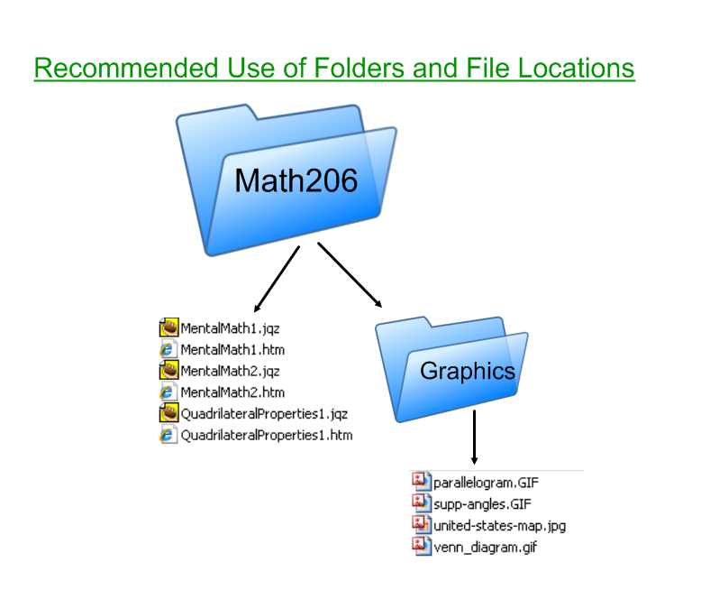

To Send Your Quizzes to Someone Else (attach in an e-mail)
- If it is one file (no graphics), just send the .htm file. You may want to send the .jqz file so the other person can edit/add to the quiz.
- If the quiz contains graphics (in the graphics folder) or you are sending multiple quizzes, an easy way to do it is:
- Go to the main folder in Windows Explorer (in our examples it has been "Math206").
- Select ALL the files and the graphics folder.
- Right-click|Send to|Compressed (zipped) folder (the zipped folder will be created).
- E-mail the zipped folder (as an attachment) to whoever you want.

