DS-303
Practice exam 2
Fall 2009 Name__________________________
1. Florida reappraises real Estate every year, and the county appraiser’s Web site lists the current “fair market value” of each piece of property. Property usually sells for somewhat more than the appraised market value. Here are the appraised market values and actual selling prices of condominium units sold in a beach front building over a 19- month period (in thousands of dollars):

Selling Price | Appraised Value
850 | 758
900 | 812.7
625 | 504
1075 | 956.7
890 | 747.9
810 | 717.7
650 | 576.6
845 | 648.3
790 | 605.9
700 | 483.8
715 | 585.8
825 | 707.6
675 | 493.9
1050 | 802.6
1325 | 1031.8
845 | 586.7

Scatterplot of the data and some summary statistics is given bellow.
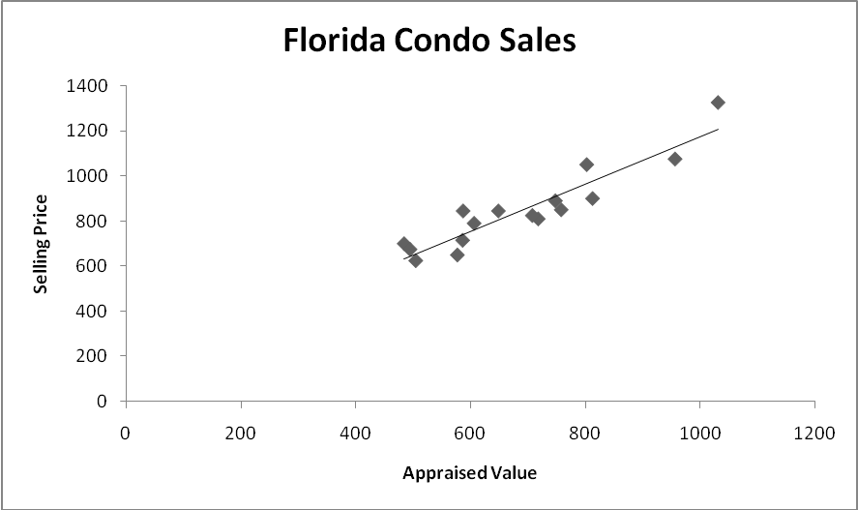

$\sum_{i=1}^{\text{16}}{x=\text{11020} }$ $\sum_{i=1}^{\text{16}}{x_{i}^{2}}=\text{7973513}\text{.}\text{08}$ $\sum_{i=1}^{\text{16}}{x_{i}y_{i}}=\text{9747701}$

$\sum_{i=1}^{\text{16}}{y_{i}}=\text{13570}$ $\sum_{i=1}^{\text{16}}{y_{i}^{2}}=\text{11997200}$

- Which is the explanatory variable?

Appraised Value

- Which is the response variable?

Selling price

- Calculate the correlation between the selling price and appraised value of condominiums sold.

$$\begin{aligned}\bar{x}=\frac{\text{11020}}{\text{16}}=\text{688}\text{.}\text{75} \bar{y}=\frac{\text{13570}}{\text{16}}=\text{848}\text{.}\text{125} \\ S_{x}=\sqrt{\frac{\sum{x^{2}−\frac{(\sum{x})^{2}}{n}}}{n−1}}=\sqrt{\frac{\text{7973513}\text{.}\text{08}−\frac{(\text{11020})^{2}}{\text{16}}}{\text{15}}}=\text{159}\text{.}\text{893} \\ S_{y}=\sqrt{\frac{\text{11997200}−\frac{(\text{13570})^{2}}{\text{16}}}{\text{15}}}=\text{180}\text{.}\text{897}\end{aligned}$$

$$\begin{aligned}r=\frac{\sum{\text{xy}−n\bar{x}\bar{y}}}{(n−1)S_{x}S_{y}} \\ r=\frac{\text{9747701}−\text{16}(\text{688}\text{.}\text{75})(\text{848}\text{.}\text{125})}{\text{15}(\text{159}\text{.}\text{893})(\text{180}\text{.}\text{397})}=\text{.}\text{9277}\end{aligned}$$

- Calculate the slope of the least square regression line fitted to this data set. Explain what it means.

$$b=r\frac{S_{y}}{S_{X}}=\text{.}\text{9277}\frac{\text{180}\text{.}\text{897}}{\text{159}\text{.}\text{893}}=1\text{.}\text{05}$$

Slope b means for every $1000 increase in appraised value the average selling price goes up by $1050.

- Calculate the intercept of the least square regression line fitted to this data set?

$$a=\bar{y}−b\bar{x}=\text{848}\text{.}\text{125}−1\text{.}\text{05}(\text{688}\text{.}\text{75})=\text{124}\text{.}\text{94}$$

- Give the equation of the least square regression line for this data set.

$$\hat{y}=a+\text{bx}⇒\text{ selling Price}= \text{124}\text{.}\text{94}+1\text{.}\text{05}(\text{Appraised value})$$

- A unit in this building has appraised value $802600. What do you predict that it will sell for?

$$\begin{aligned}\text{selling price }=\text{124}\text{.}\text{94}+1\text{.}\text{05}(\text{802}\text{.}6)=\text{967}\text{.}\text{67} \\ \$\text{967670}\end{aligned}$$

- Do you think that this model accurately predict the selling price? Calculate R² and use the value you get to support your answer.

$$R^{2}=(\text{.}\text{9277})^{2}=\text{.}\text{861}$$
86.1% of the variability in the selling price is due to the appraised value, only 14% is due to other factors. This implies that the predicted values based on the above equation are relatively accurate.
2. Eugene Gates, Marketing Director of Mansfield Motors Manufacturers, Inc.’s Electrical Division, is leading a study to assess the relative importance of product features. An item on a survey questionnaire distributed to 121 of Mansfield’s customers asked them to rate the importance of “ease of maintenance” on a scale of 1 to 10 (with 1 meaning “not important” and 10 meaning “highly important”). His staff assembled the following statistics.
 | Ease of Maintenance
Mean | 7.5
Standard Deviation | 1.1

Find the 95% confidence interval for the population mean rating of “ease of maintenance”.

$$\begin{aligned}\bar{x}±z^{}\frac{s}{\sqrt{n}} \\ 7\text{.}5±1\text{.}\text{96}(\frac{1\text{.}1}{\sqrt{\text{121}}}) \\ 7\text{.}5±\text{.}\text{196} \\ (7\text{.}\text{304}, 7\text{.}\text{696})\end{aligned}$$

- Bags of a certain brand of tortilla chips claim to have a net weight of 14 ounces. Net weights actually vary slightly from bag to bag and are normally distributed with mean µ. A representative of a consumer advocate group wishes to see if there is any evidence that the mean net weight is less than advertised. To this, he selects 16 bags of this brand at random and determines the net weight of each. He finds the sample mean to be 13.88 and the sample standard deviation to be s = .24. Is there significant evidence at 5% level that the mean net weight for a bag of tortilla chips for this brand is less than 14 ounces? State the null and the alternative hypothesis, report the value of your test statistics, the corresponding p-value, and your conclusion.

Null and alternative Hypothesis:

H₀: μ = 14

H₁ : µ < 14

Test Statistics:

$$T=\frac{\bar{x}−μ_{0}}{\frac{s}{\sqrt{n}}}=\frac{\text{13}\text{.}\text{88}−\text{14}}{\frac{\text{.}\text{24}}{\sqrt{\text{16}}}}=−2$$

P-value

p-valu =$P((T|>2)⇒ \text{.}\text{025}≤p−\text{value}≤\text{.}\text{05}$

Conclusion:
Reject Ho. The mean net weight is less than advertised.

Multiple Choice Questions
Select the best Answer.

Use the following to answer questions 5 and 6:

The height (in feet) and volume of usable lumber (in cubic feet) of 32 cherry trees are measured by a researcher. The goal is to determine if volume of usable lumber can be estimated from the height of a tree. The results are plotted below.

5. | In this study, the response variable is
A) | height.
B) | volume. **
C) | height or volume. It doesn't matter which is considered the response.
D) | neither height nor volume. The measuring instrument used to measure height is the response variable.

6. | The scatterplot suggests
A) | there is a positive association between height and volume.
B) | there is an outlier in the plot.
C) | both a) and b). **
D) | neither a) nor b).

7. | Which of the following is true of the correlation coefficient r?
A) | It is a resistant measure of association.
B) | –1 ≤ r ≤ 1.
C) | If r is the correlation between X and Y, then –r is the correlation between Y and X.
D) | All of the above. **

8. The z value associated with a 80% confidence interval is _______.

a. ±1.645
b. ±1.28**
c. ±0.84
- ±0.29

9. Using the same set of data, you compute a 95% confidence interval and a 99% confidence interval. Which of the following statements is correct?
- The intervals have the same width
- The 99%interval is wider**
- The 95% interval is wider
- You cannot determine which interval is wider unless you know n and standard deviation s.

10. Which of the following is NOT a continuous distribution?

a. normal distribution
b. exponential distribution
c. uniform distribution
- binomial distribution**

11. The area to the left of the mean in any normal distribution is _______.

a. equal to the mean
b. equal to 1
c. equal to the variance
- equal to 0.5**
Use the following information for problems 12 trough 14
Fully-grown southern pine trees have heights, which are normally distributed. They average 40 feet tall, with standard deviation of 6.26 feet.
12. What percentage of southern pines grow to heights between 26 and 48 feet tall?
- 0.0878
- .0082
- .8997
- .8872**
- None of the above
13. What percentage of southern pines grow taller than 60 feet tall?
- .0007**
- .0878
- .8772
- .9918
- None of the above

14. If you measure the heights of 9 pine trees, what is the probability that their average will be less than 45 feet?
- .0082
- .0007
- .9918**
- .9875
- None of the above.

15. If the P-value is larger than the level of significance level α, the null hypothesis is rejected.
(a) True (b) False** (c) Not enough information

16. You want to compute a 95% confidence interval for the mean of a population with unknown population standard deviation. The sample size is 25. The value of t* you would use for this interval is
- 1.96
- 1.711
- 2.060
- 2.064 **
- None of the above.

